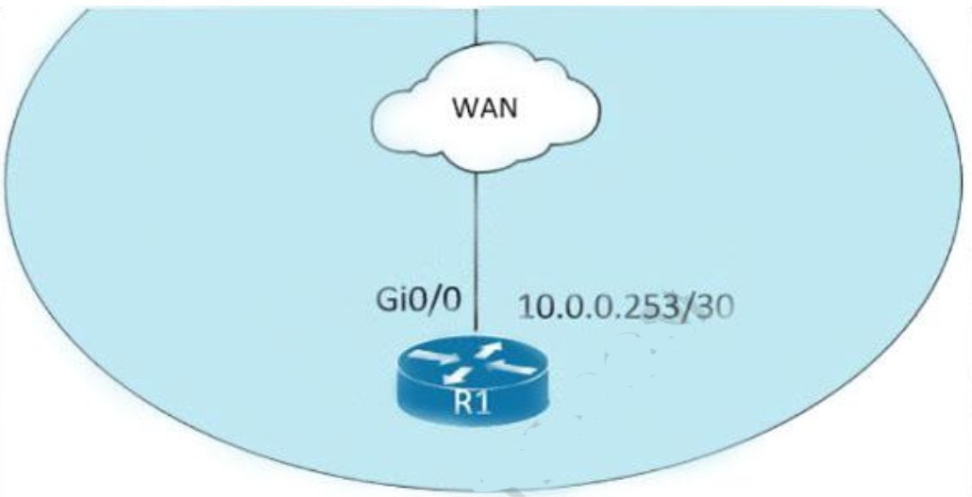

1. interface gi0/1 no cdp enable
2. interface gi0/1 clear cdp table
3. interface gi0/0 no cdp advertise-v2
4. interface gi0/0 no cdp run Answer: A
5. What is a role of access points in an enterprise network?
   1. connect wireless devices to a wired network
   2. support secure user logins to devices or the network
   3. integrate with SNMP in preventing DDoS attacks
   4. serve as a first line of defense in an enterprise network Answer: A
6. What is a similarity between OM3 and OM4 fiber optic cable?
   1. Both have a 50 micron core diameter
   2. Both have a 9 micron core diameter
   3. Both have a 62.5 micron core diameter
   4. Both have a 100 micron core diameter Answer: A
7. Refer to the exhibit.

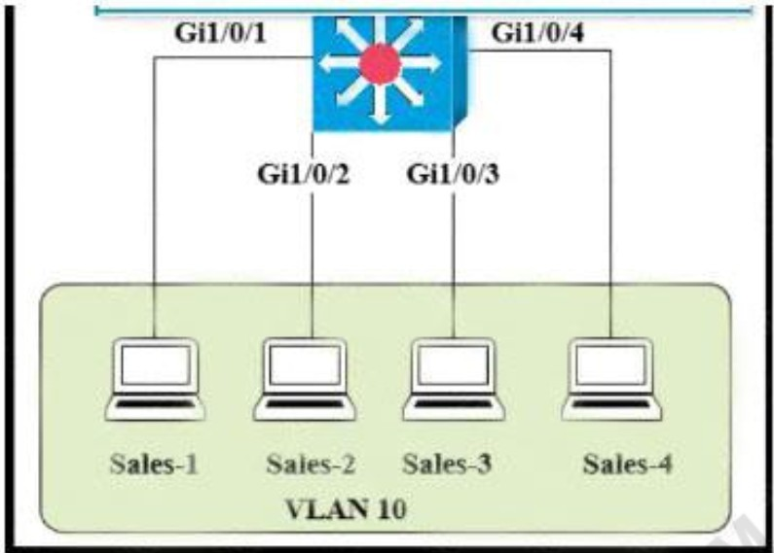

The entire contents of the MAC address table are shown. Sales-4 sends a data frame to Sales- 1.

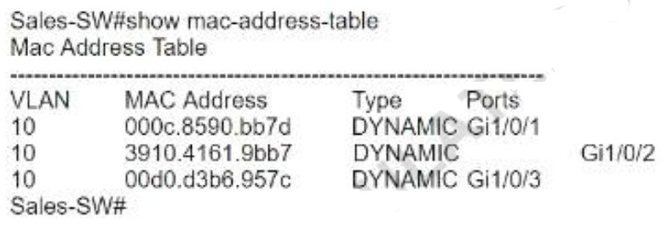

What does the switch do as it receives the frame from Sales-4?

1. Perform a lookup in the MAC address table and discard the frame due to a missing entry.
2. Insert the source MAC address and port into the forwarding table and forward the frame to Sales-1.
3. Map the Layer 2 MAC address to the Layer 3 IP address and forward the frame.
4. Flood the frame out of all ports except on the port where Sales-1 is connected. Answer: B
5. What describes the operation of virtual machines?
   1. Virtual machines are responsible for managing and allocating host hardware resources
   2. In a virtual machine environment, physical servers must run one operating system at a time.
   3. Virtual machines are the physical hardware that support a virtual environment.
   4. Virtual machines are operating system instances that are decoupled from server hardware

Answer: B

1. Refer to the exhibit. Only four switches are participating in the VLAN spanning-tree process.

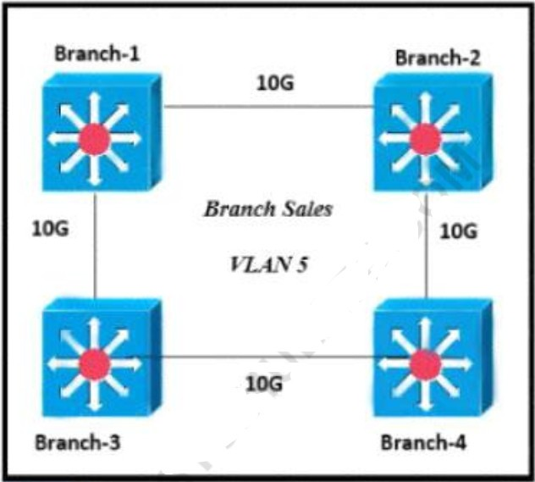

Branch-1 priority 614440

Branch-2: priority 39082416

Branch-3: priority 0 Branch-4: root primary

Which switch becomes the permanent root bridge for VLAN 5?

* 1. Branch-1
  2. Branch-2
  3. Branch-3
  4. Branch-4 Answer: C

1. When deploying syslog, which severity level logs informational message?
   1. 0
   2. 2
   3. 4
   4. 6 Answer: D
2. Refer to the exhibit. Shortly after SiteA was connected to SiteB over a new single-mode fiber path users at SiteA report intermittent connectivity issues with applications hosted at SiteB What is the cause of the intermittent connectivity issue?

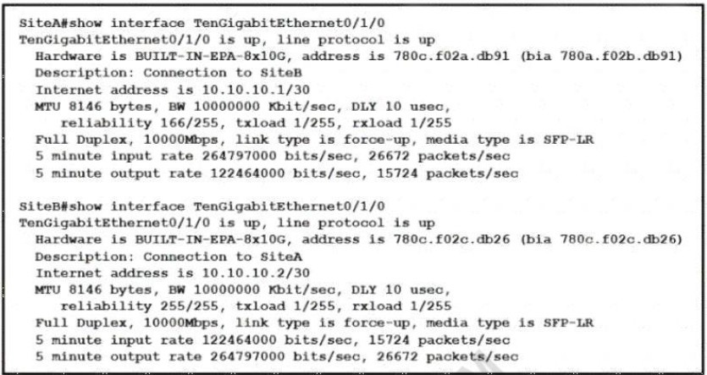

* 1. Interface errors are incrementing
  2. An incorrect SFP media type was used at SiteA
  3. High usage is causing high latency
  4. The sites were connected with the wrong cable type Answer: A

Explanation: reliability 255/255: When the input and output errors increase, they affect the reliability counter. This indicates how likely it is that a packet can be delivered or received succesfully. Reliability is calculated like this: reliability = number of packets / number of total frames. The value of 255 is the highest value meaning that the interface is very reliable at the moment. The calculation above is done every 5 minutes.

1. 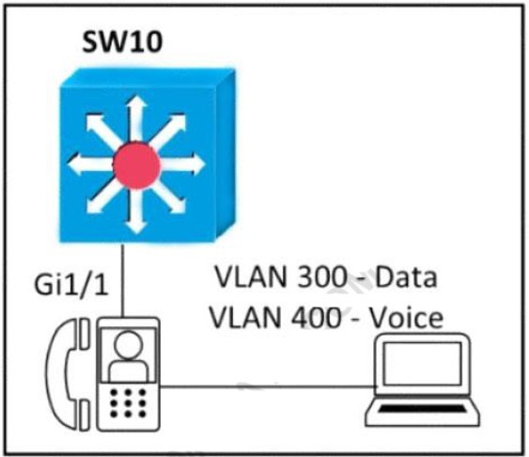Refer to the exhibit. An engineer must configure GigabitEthernet1/1 to accommodate voice and data traffic Which configuration accomplishes this task?

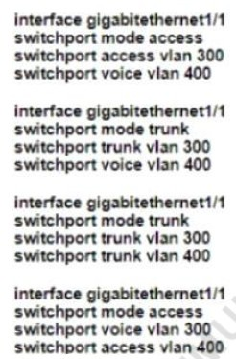

* 1. Option A
  2. Option B
  3. Option C
  4. Option D Answer: A

1. Which technology is appropriate for communication between an SDN controller and applications running over the network?
   1. OpenFlow
   2. REST API
   3. NETCONF
   4. Southbound API Answer: B
2. Which security program element involves installing badge readers on data-center doors to allow workers to enter and exit based on their job roles?
   1. role-based access control
   2. biometrics
   3. multifactor authentication
   4. physical access control Answer: D
3. Which network action occurs within the data plane?
   1. compare the destination IP address to the IP routing table.
   2. run routing protocols (OSPF, EIGRP, RIP, BGP)
   3. make a configuration change from an incoming NETCONF RPC
   4. reply to an incoming ICMP echo request Answer: A
4. Which networking function occurs on the data plane?
   1. forwarding remote client/server traffic
   2. facilitates spanning-tree elections
   3. processing inbound SSH management traffic
   4. sending and receiving OSPF Hello packets Answer: A
5. 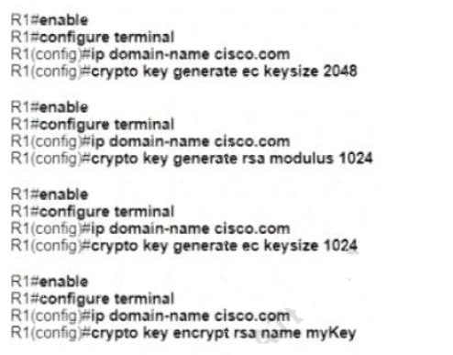A network administrator must to configure SSH for remote access to router R1 The requirement is to use a public and private key pair to encrypt management traffic to and from the connecting client. Which configuration, when applied, meets the requirements?
   1. Option A
   2. Option B
   3. Option C
   4. Option D Answer: B
6. Which protocol does an access point use to draw power from a connected switch?
   1. Internet Group Management Protocol
   2. Adaptive Wireless Path Protocol
   3. Cisco Discovery Protocol
   4. Neighbor Discovery Protocol Answer: C
7. What is the benefit of using FHRP?
   1. reduced management overhead on network routers
   2. balancing traffic across multiple gateways in proportion to their loads
   3. higher degree of availability
   4. reduced ARP traffic on the network Answer: C
8. An administrator must secure the WLC from receiving spoofed association requests. Which steps must be taken to configure the WLC to restrict the requests and force the user to wait 10 ms to retry an association request?
   1. Enable Security Association Teardown Protection and set the SA Query timeout to 10
   2. Enable MAC filtering and set the SA Query timeout to 10
   3. Enable 802.1x Layer 2 security and set me Comeback timer to 10
   4. Enable the Protected Management Frame service and set the Comeback timer to 10 Answer: C
9. A network engineer must configure the router R1 GigabitEthernet1/1 interface to connect to the router R2 GigabitEthernet1/1 interface. For the configuration to be applied the engineer must compress the address 2001:0db8:0000:0000:0500:000a:400F:583B. Which command must be issued on the interface?
   1. ipv6 address 2001:0db8::5: a: 4F 583B

B. ipv6 address 2001:db8::500:a:400F:583B

C. ipv6 address 2001 db8:0::500:a:4F:583B

D. ipv6 address 2001::db8:0000::500:a:400F:583B

Answer: B

1. What does an SDN controller use as a communication protocol to relay forwarding changes to a southbound API?
   1. OpenFlow
   2. Java
   3. REST
   4. XML Answer: A
2. What uses HTTP messages to transfer data to applications residing on different hosts?
   1. OpenFlow
   2. OpenStack
   3. OpFlex
   4. REST Answer: D
3. When a WLAN with WPA2 PSK is configured in the Wireless LAN Controller GUI which format is supported?
   1. Unicode
   2. base64
   3. decimal
   4. ASCII Answer: D
4. Which 802.11 management frame type is sent when a client roams between access points on the same SSID?
   1. Reassociation Request
   2. Probe Request
   3. Authentication Request
   4. Association Request Answer: A
5. An engineer observes high usage on the 2.4GHz channels and lower usage on the 5GHz channels. What must be configured to allow clients to preferentially use 5GHz access points?
   1. Re- Anchor Roamed Clients
   2. 11ac MU-MIMO
   3. OEAP Split Tunnel
   4. Client Band Select Answer: D
6. What is a characteristic of private IPv4 addressing?
   1. traverse the Internet when an outbound ACL is applied
   2. issued by IANA in conjunction with an autonomous system number
   3. composed of up to 65.536 available addresses
   4. used without tracking or registration Answer: D
7. 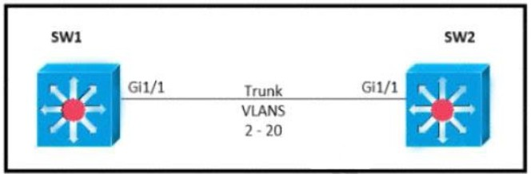Refer to the exhibit. Which command must be executed for Gi1.1 on SW1 to become a trunk port if Gi1/1 on SW2 is configured in desirable or trunk mode?
   1. switchport mode trunk
   2. switchport mode dot1-tunnel
   3. switchport mode dynamic auto
   4. switchport mode dynamic desirable Answer: C
8. What are two improvements provided by automation for network management in an SDN environment? (Choose two)
   1. Data collection and analysis tools establish a baseline for the network
   2. Artificial intelligence identifies and prevents potential design failures.
   3. Machine learning minimizes the overall error rate when automating troubleshooting processes
   4. New devices are onboarded with minimal effort
   5. Proprietary Cisco APIs leverage multiple network management tools. Answer: B E
9. An engineer must configure the IPv6 address 2001:0db8:0000:0000:0700:0003:400F:572B on the serial0/0 interface of the HQ router and wants to compress it for easier configuration. Which command must be issued on the router interface?

A. ipv6 address 2001:db8::700:3:400F:572B

B. ipv6 address 2001:db8:0::700:3:4F:572B

C. ipv6 address 2001:Odb8::7:3:4F:572B

D. ipv6 address 2001::db8:0000::700:3:400F:572B

Answer: A

1. Which WLC port connects to a switch to pass normal access-point traffic?
2. redundancy
3. console
4. distribution system
5. service Answer: C
6. An engineering team asks an implementer to configure syslog for warning conditions and error conditions. Which command does the implementer configure to achieve the desired result?
7. logging trap 5
8. logging trap 2
9. logging trap 4
10. logging trap 3 Correct Answer: C
11. Which two protocols are supported on service-port interfaces? (Choose two.)
12. RADIUS
13. TACACS+
14. SCP
15. Telnet
16. SSH

Correct Answer: D E

1. 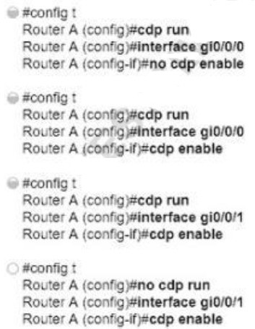Refer to the exhibit. How must router A be configured so that it only sends Cisco Discovery Protocol Information to router C

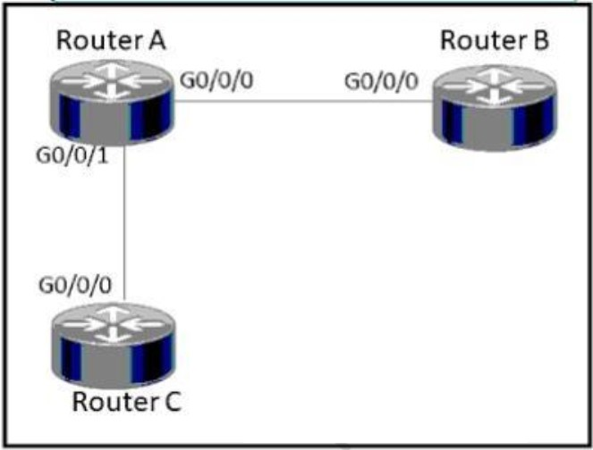

1. Option A
2. Option B
3. Option C
4. Option D Answer: A

Q454

Which global command encrypt all passwords in the running configuration?

* 1. password-encrypt
  2. enable password-encryption
  3. enable secret
  4. service password-encryption Answer: D

Q455

What is the function of a hub-and-spoke WAN topology?

1. allows access restrictions to be implemented between subscriber sites.
2. provides direct connections between subscribers
3. supports Layer 2 VPNs
4. supports application optimization Answer: B

## An implementer is preparing hardware for virtualization to create virtual machines on a host. What is needed to provide communication between hardware and virtual machines?

* + A. hypervisor
  + B. router
  + C. straight cable
  + D. switch Answer: A

## Which two components are needed to create an Ansible script that configures a VLAN on a switch? (Choose two.)

* + A. cookbook
  + B. task
  + C. playbook
  + D. model
  + E. recipe Answer: B C

**Explanation:** Ansible playbooks: “files that provide actions and logic about what Ansible should do.”

“The playbook will list tasks and choices based on those results, like “Configure all branch routers in these locations, and if errors occur for any device, do these extra tasks for that device”.”

## Refer to the exhibit. Which two prefixes are included in this routing table entry? (Choose two.)

* + A. 192.168.1.17
  + B. 192.168.1.61
  + C. 192.168.1.64
  + D. 192.168.1.127
  + E. 192.168.1.254

Answer: AB

## Which two primary drivers support the need for network automation? (Choose two.)

* + A. Eliminating training needs
  + B. Increasing reliance on self-diagnostic and self-healing
  + C. Policy-derived provisioning of resources
  + D. Providing a ship entry point for resource provisioning
  + E. Reducing hardware footprint Answer: C D

## What is a characteristic of cloud-based network topology?

* + A. wireless connections provide the sole access method to services
  + B. onsite network services are provided with physical Layer 2 and Layer 3 components
  + C. services are provided by a public, private, or hybrid deployment
  + D. physical workstations are configured to share resources Answer: C

## A network analyst is tasked with configured the date and time on a router using EXEC mode. The date must be set to 12:00am. Which command should be used?

* + A. Clock timezone
  + B. Clock summer-time-recurring
  + C. Clock summer-time date
  + D. Clock set Answer: D

## Which HTTP status code is returned after a successful REST API request?

* + A. 200
  + B. 301
  + C. 404
  + D. 500

Answer: A

## Refer to the exhibit. When PC-A sends traffic to PC-B, which network component is in charge of receiving the packet from PC-A verifying the IP addresses, and forwarding the packet to PC-B?

* + A. Layer 2 switch
  + B. Router
  + C. Load balancer
  + D. firewall Answer: B

## What is the function of a controller in controller-based networking?

* + A. It serves as the centralized management point of an SDN architecture.
  + B. It centralizes the data plane for the network.
  + C. It is the card on a core router that maintains all routing decisions for a campus.
  + D. It is a pair of core routers that maintain all routing decisions for a campus Answer: A

## Refer to me exhibit. Which action is taken by the router when a packet is sourced from 10.10.10.2 and destined for 10.10.10.16?

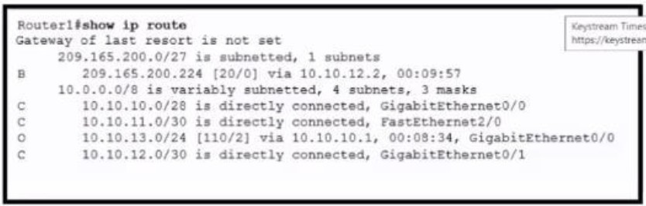

* + A. It uses a route that is similar to the destination address
  + B. It discards the packets.
  + C. It floods packets to all learned next hops.
  + D. It Queues the packets waiting for the route to be learned. Answer: B

**Explanation:** Referring to routing table, 10.10.10.0/28 supports network from 10.10.10.0- 10.10.10.15.

Gateway of last resort is not set

So traffic destined to 10.10.10.16 will be discarded.

## When a switch receives a frame for a known destination MAC address, how is the frame handed?

* + A. sent to the port identified for the known MAC address
  + B. broadcast to all ports
  + C. forwarded to the first available port
  + D. flooded to all ports except the one from which it originated Answer: A

**Explanation/Reference:** A switch builds its MAC address table by recording the MAC address of each device connected to each of its ports. The switch uses the information in the MAC address table to send frames destined for a specific device out the port, which has been assigned to that device.

Reference: [Click here](https://www.ciscopress.com/articles/article.asp?p=2181835&seqNum=5)

## Why was the RFC 1918 address space defined?

* + A. conserve public IPv4 addressing
  + B. preserve public IPv6 address space
  + C. reduce instances of overlapping IP addresses
  + D. support the NAT protocol Answer: A

## Refer to the exhibit. R5 is the current DR on the network, and R4 is the BDR. Their interfaces are flapping, so a network engineer wants the OSPF network to elect a different DR and BDR. Which set of configurations must the engineer implement?

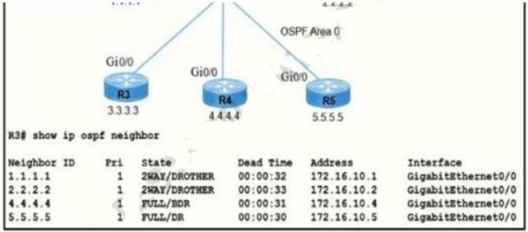

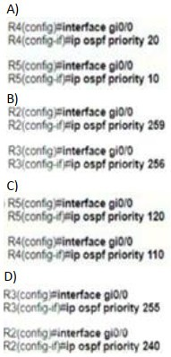

* + A. Option
  + B. Option
  + C. Option
  + D. Option Answer: D

## After installing a new Cisco ISE server, which task must the engineer perform on the Cisco WLC to connect wireless clients on a specific VLAN based on their credentials?

* + A. Enable the allow AAA Override
  + B. Enable the Even: Driven RRM.
  + C. Disable the LAG Mode or Next Reboot.
  + D. Enable the Authorized MIC APs against auth-list or AAA. Answer: A

## Which level of severity must be set to get informational syslogs?

* + A. alert
  + B. critical
  + C. notice
  + D. debug Answer: D

**Explanation/Reference:** Specifying a level causes messages at that level and numerically lower levels to be displayed at the destination.

From Table 3 : informational level = 6, debugging level = 7, notice/notifications level = 5 Reference: [Click here](https://www.cisco.com/c/en/us/td/docs/routers/access/wireless/software/guide/SysMsgLogging.html)

## Refer to the exhibit. Router R4 is dynamically learning the path to the server. If R4 is connected to R1 via OSPF Area 20, to R2 via R2 BGP, and to R3 via EIGRP 777, which path is installed in the routing table of R4?

* + A. the path through R1, because the OSPF administrative distance is 110
  + B. the path through R2. because the IBGP administrative distance is 200
  + C. the path through R2 because the EBGP administrative distance is 20
  + D. the path through R3. because the EIGRP administrative distance is lower than OSPF and BGP

Answer: C

## What is a function of the Cisco DNA Center Overall Health Dashboard?

* + A. It provides a summary of the top 10 global issues.
  + B. It provides detailed activity logging for the 10 devices and users on the network.
  + C. It summarizes the operational status of each wireless devise on the network.
  + D. It summarizes daily and weekly CPU usage for servers and workstations in the network.

Answer: A

## Which protocol requires authentication to transfer a backup configuration file from a router to a remote server?

* + A. DTP
  + B. FTP
  + C. SMTP
  + D. TFTP Answer: B

## Where is the interface between the control plane and data plane within the softwaredefined architecture?

* + A. control layer and the infrastructure layer
  + B. application layer and the infrastructure layer
  + C. control layer and the application layer
  + D. application layer and the management layer Answer: A

## Which action does the router take as rt forwards a packet through the network?

* + A. The router replaces the source and desinaoon labels wth the sending router uterface label as a source and the next hop router label as a desbnabon
  + B. The router encapsulates the source and destination IP addresses with the sending router P address as the source and the neighbor IP address as the destination
  + C. The router replaces the original source and destination MAC addresses with the sending router MAC address as the source and neighbor MAC address as the destination
  + D. The router encapsulates the original packet and then includes a tag that identifies the source router MAC address and transmit transparently to the destination

Answer: C

## When a site-to-site VPN is configured, which IPsec mode provides encapsulation and encryption of the entire original P packet?

* + A. IPsec tunnel mode with AH
  + B. IPsec transport mode with AH
  + C. IPsec tunnel mode with ESP
  + D. IPsec transport mode with ESP Answer: C

## Refer to the exhibit. Which two commands, when configured on router R1, fulfill these requirements? (Choose two.)

**Packets towards the entire network 2001:db8:2::/64 must be forwarded through router R2.**

**Packets toward host 2001:db8:23::14 preferably must be forwarded through R3.**

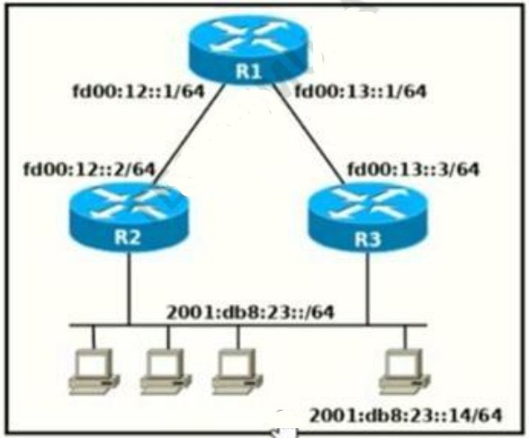

* + A. Ipv6 route 2001:db8:23::/128 fd00:12::2
  + B. Ipv6 route 2001:db8:23::14/128 fd00:13::3
  + C. Ipv6 route 2001:db8:23::14/64 fd00:12::2
  + D. Ipv6 route 2001:db8:23::/64 fd00:12::2
  + E. Ipv6 route 2001:db8:23::14/64 fd00:12::2 200 Answer: B D

**Explanation/Reference:** We choose option B instead of option D because the destination is a host. Therefore, we use a host route meaning that all bits of the ipv6 destination address must match (prefix-length of /128). Also, the next hop address should be that of R3 (fd00:13::3) since the question asks that packets for the host must be forwarded through it.

## What is the role of a firewall in an enterprise network?

* + A. Forwards packets based on stateless packet inspection
  + B. Processes unauthorized packets and allows passage to less secure segments of the network
  + C. determines which packets are allowed to cross from unsecured to secured networks
  + D. explicitly denies all packets from entering an administrative domain Answer: C

## What is the benefit of configuring PortFast on an interface?

* + A. After the cable is connected, the interface uses the fastest speed setting available

for that cable type

* + B. After the cable is connected, the interface is available faster to send and receive user data
  + C. The frames entering the interface are marked with higher priority and then processed faster by a switch.
  + D. Real-time voice and video frames entering the interface are processed faster Answer: B

## How are VLAN hopping attacks mitigated?

* + A. enable dynamic ARP inspection
  + B. manually implement trunk ports and disable DTP
  + C. activate all ports and place in the default VLAN
  + D. configure extended VLANs Answer: B

## Which two protocols must be disabled to increase security for management connections to a Wireless LAN Controller? (Choose two)

* + A. Telnet
  + B. SSH
  + C. HTTP
  + D. HTTPS
  + E. TFTP Answer: A C

## When a client and server are not on the same physical network, which device is used to forward requests and replies between client and server for DHCP?

* + A. DHCP relay agent
  + B. DHCP server
  + C. DHCPDISCOVER
  + D. DHCPOFFER Answer: A

## Which QoS tool is used to optimize voice traffic on a network that is primarily intended for data traffic?

* + A. FIFO
  + B. WFQ
  + C. PQ
  + D. WRED Answer: C

## On workstations running Microsoft Windows, which protocol provides the default gateway for the device?

* + A. DHCP
  + B. STP
  + C. SNMP
  + D. DNS Answer: A

## What is the purpose of using First Hop Redundancy Protocol in a specific subnet?

* + A. Filter traffic based on destination IP addressing
  + B. Sends the default route to the hosts on a network
  + C. ensures a loop-free physical topology
  + D. forwards multicast hello messages between routers Answer: D

## What is the difference in data transmission delivery and reliability between TCP and UDP?

* + A. TCP transmits data at a higher rate and ensures packet delivery. UDP retransmits lost data to ensure applications receive the data on the remote end.
  + B. UDP sets up a connection between both devices before transmitting data. TCP uses the three-way handshake to transmit data with a reliable connection.
  + C. UDP is used for multicast and broadcast communication. TCP is used for unicast communication and transmits data at a higher rate with error checking.
  + D. TCP requires the connection to be established before transmitting data. UDP transmits data at a higher rate without ensuring packet delivery.

Answer: D

## How does QoS optimize voice traffic?

* + A. reducing bandwidth usage
  + B. by reducing packet loss
  + C. by differentiating voice and video traffic
  + D. by increasing jitter Answer: C

## What are network endpoints?

* + A. act as routers to connect a user to the service prowler network
  + B. a threat to the network if they are compromised
  + C. support inter-VLAN connectivity
  + D. enforce policies for campus-wide traffic going to the internet Answer: B

## What does physical access control regulate?

* + A. access to spec fie networks based on business function
  + B. access to servers to prevent malicious activity
  + C. access :o computer networks and file systems
  + D. access to networking equipment and facilities Answer: D

## What must be considered when using 802.11a?

* + A. It is compatible with 802 lib- and 802 11-compliant wireless devices
  + B. It is used in place of 802 11b/g when many nonoverlapping channels are required
  + C. It is susceptible to interference from 2 4 GHz devices such as microwave ovens.
  + D. It is chosen over 802 11b/g when a lower-cost solution is necessary Answer: B

**Explanation/Reference:** 802.11a and 802.11b are not compatible since 802.11a operates at the 5GHz frequency band and 802.11b operates at the 2.4GHz band. The 2.4 GHz frequency band with a channel width of 22 MHz only has 3 non-overlapping channels (1, 6 and 11) whereas the 5 GHz band has 23 non-overlapping channels with a 20 MHz channel width. Therefore, 802.11a is preferred over 802.11b and 802.11g when many non-overlapping

channels are required since they both operate at 2.4GHz unlike 802.11a.

## An engineer configures interface Gi1/0 on the company PE router to connect to an ISP Neighbor discovery is disabled. Which action is necessary to complete the configuration if the ISP uses third-party network devices?

* + A. Enable LLDP globally
  + B. Disable autonegotiation
  + C. Disable Cisco Discovery Protocol on the interface
  + D. Enable LLDP-MED on the ISP device Answer: D

## Which two events occur automatically when a device Is added to Cisco DNA Center? (Choose two.)

* + A. The device Is assigned to the Global site.
  + B. The device Is placed into the Unmanaged state.
  + C. The device Is placed into the Provisioned state.
  + D. The device Is placed into the Managed state.
  + E. The device is assigned to the Local site. Answer: A D

## What are two benefits of using the PortFast feature? (Choose two)

* + A. Enabled interfaces are automatically placed in listening state
  + B. Enabled interfaces come up and move to the forwarding state immediately
  + C. Enabled interfaces never generate topology change notifications.
  + D. Enabled interfaces that move to the learning state generate switch topology change notifications
  + E. Enabled interfaces wait 50 seconds before they move to the forwarding state Answer: B C

**Explanation/Reference:** “A switch will never generate a topology change notification for an interface that has portfast enabled.”

Source: [Click here](https://networklessons.com/switching/cisco-portfast-configuration)

“Another major benefit of the STP portfast feature is that the access ports bypass the earlier 802.1D STP states (learning and listening) and forward traffic immediately.”

Source: [Click here](https://www.ciscopress.com/articles/article.asp?p=2995351&seqNum=3)

## A network administrator is asked to configure VLANS 2, 3 and 4 for a new

**implementation. Some ports must be assigned to the new VLANS with unused remaining. Which action should be taken for the unused ports?**

* + A. configure port in the native VLAN
  + B. configure ports in a black hole VLAN
  + C. configure in a nondefault native VLAN
  + D. configure ports as access ports Answer: B

## Which function is performed by DHCP snooping?

* + A. propagates VLAN information between switches
  + B. listens to multicast traffic for packet forwarding
  + C. provides DDoS mitigation
  + D. rate-limits certain traffic Answer: D

## Which plane is centralized by an SON controller?

* + A. management-plane
  + B. control-plane
  + C. data-plane
  + D. services-plane Answer: B

## Which access layer threat-mitigation technique provides security based on identity?

* + A. Dynamic ARP Inspection
  + B. using a non-default native VLAN
  + C. 802.1x
  + D. DHCP snooping Answer: C

## What are two similarities between UTP Cat 5e and Cat 6a cabling? (Choose two.)

* + A. Both operate at a frequency of 500 MHz.
  + B. Both support runs of up to 55 meters.
  + C. Both support runs of up to 100 meters.
  + D. Both support speeds of at least 1 Gigabit.
  + E. Both support speeds up to 10 Gigabit. Answer: C D

## Refer to the exhibit. What is the metric of the route to the 192.168.10.33/28 subnet?

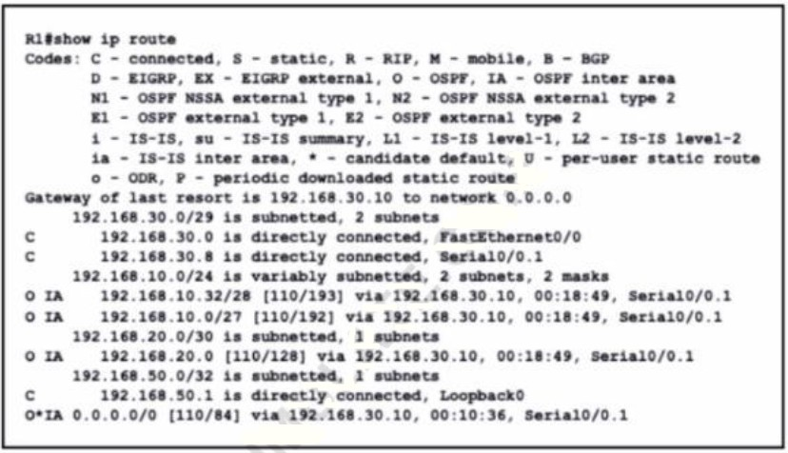

* + A. 84
  + B. 110
  + C. 128
  + D. 192
  + E. 193

Answer: E

## What are two characteristics of the distribution layer in a three-tier network architecture? (Choose two.)

* + A. serves as the network aggregation point
  + B. provides a boundary between Layer 2 and Layer 3 communications
  + C. designed to meet continuous, redundant uptime requirements
  + D. is the backbone for the network topology
  + E. physical connection point for a LAN printer Answer: AB

**Explanation/Reference:** The **distribution layer** aggregates the data received from the access layer switches before it is transmitted to the core layer for routing to its final destination. In Figure 1-6, the distribution layer is the boundary between the Layer 2 domains and the Layer 3 routed network.

Reference: [Click here](https://www.ciscopress.com/articles/article.asp?p=2202410&seqNum=4)

1. What prevents a workstation from receiving a DHCP address?
2. DTP
3. STP
4. VTP

D. 802.10

Answer: B

1. What Is a syslog facility?
2. Host that is configured for the system to send log messages
3. password that authenticates a Network Management System to receive log messages
4. group of log messages associated with the configured severity level
5. set of values that represent the processes that can generate a log message Answer: D
6. Which communication interaction takes place when a southbound API Is used?
7. between the SDN controller and PCs on the network
8. between the SON controller and switches and routers on the network
9. between the SON controller and services and applications on the network
10. between network applications and switches and routers on the network Answer: B
11. Which port type supports the spanning-tree portfast command without additional configuration?
12. access ports
13. Layer 3 main Interfaces
14. Layer 3 suninterfaces
15. trunk ports Answer: A
16. An engineer is configuring data and voice services to pass through the same port. The designated switch interface fastethernet0/1 must transmit packets using the same priority for data when they are received from the access port of the IP phone. Which configuration must be used?

A)

interface fastethernet0/1 switchport priority extend cos 7 B)

interface fastethernet0/1 switchport voice vlan untagged C)

interface fastethernet0/1 switchport voice vlan dot1p D)

interface fastethernet0/1 switchport priority extend trust Answer: A

1. Which mode must be set for APs to communicate to a Wireless LAN Controller using the Control and Provisioning of Wireless Access Points (CAPWAP) protocol?
2. bridge
3. route
4. autonomous
5. lightweight Answer: D
6. What are two benefits of FHRPs? (Choose two.)
7. They prevent (oops in the Layer 2 network.
8. They allow encrypted traffic.
9. They are able to bundle muftlple ports to increase bandwidth
10. They enable automatic failover of the default gateway.
11. They allow multiple devices lo serve as a single virtual gateway for clients in the network Answer: D,E
12. What are two characteristics of an SSID? (Choose Two)
13. It can be hidden or broadcast in a WLAN
14. It uniquely identifies an access point in a WLAN
15. It uniquely identifies a client in a WLAN
16. It is at most 32 characters long.
17. IT provides secured access to a WLAN Answer: A, D
18. In QoS, which prioritization method is appropriate for interactive voice and video?
19. expedited forwarding
20. traffic policing
21. round-robin scheduling
22. low-latency queuing Answer: D
23. 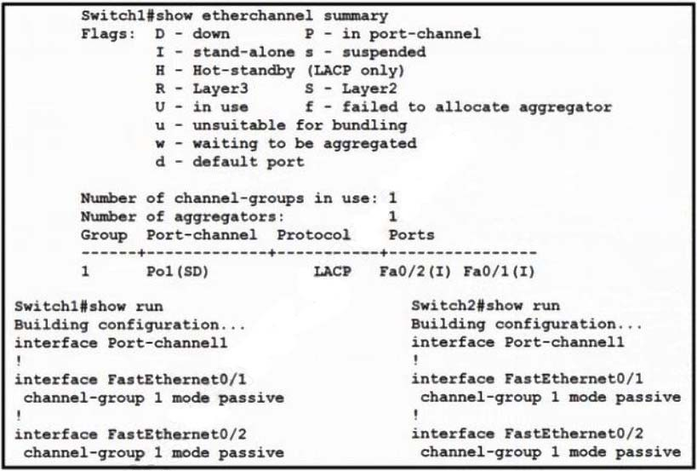Refer to the exhibit. Which change to the configuration on Switch allows the two switches to establish an GtherChannel?
24. Change the protocol to EtherChannel mode on.
25. Change the LACP mode to active
26. Change the LACP mode to desirable
27. Change the protocol to PAqP and use auto mode

Answer: B

1. What Is the path for traffic sent from one user workstation to another workstation on a separate switch In a Ihree- lter architecture model?
2. access – core – distribution – access
3. access – distribution – distribution – access
4. access – core – access
5. access -distribution – core – distribution – access Answer: D
6. How does WPA3 improve security?
7. It uses SAE for authentication.
8. It uses a 4-way handshake for authentication.
9. It uses RC4 for encryption.
10. It uses TKIP for encryption. Answer: A
11. Where does wireless authentication happen?
12. SSID
13. radio
14. band
15. Layer 2 Answer: D
16. How are the switches in a spine-and-leaf topology interconnected?
17. Each leaf switch is connected to one of the spine switches.
18. Each leaf switch is connected to two spine switches, making a loop.
19. Each leaf switch is connected to each spine switch.
20. Each leaf switch is connected to a central leaf switch, then uplinked to a core spine switch. Answer: C
21. What are two characteristics of a public cloud Implementation? (Choose two.)
22. It is owned and maintained by one party, but it is shared among multiple organizations.
23. It enables an organization to fully customize how It deploys network resources.
24. It provides services that are accessed over the Internet.
25. It Is a data center on the public Internet that maintains cloud services for only one company.
26. It supports network resources from a centralized third-party provider and privately-owned virtual resources Answer: C,E
27. Which virtual MAC address is used by VRRP group 1? A. 0050.0c05.ad81

B. 0007.c061.bc01

C. 0000.5E00.0101

D. 0500.3976.6401

Answer: C

1. Which type of traffic Is sent with pure iPsec?
2. broadcast packets from a switch that is attempting to locate a MAC address at one of several remote sites
3. multicast traffic from a server at one site to hosts at another location
4. spanning-tree updates between switches that are at two different sites
5. unicast messages from a host at a remote site lo a server at headquarters Answer: D
6. What is the purpose of an SSID?
7. It provides network security
8. It differentiates traffic entering access posits
9. It identities an individual access point on a WLAN
10. It identifies a WLAN Answer: D
11. What is a similarly between 1000BASE-LX and 1000BASE-T standards?
12. Both use the same data-link header and trailer formats
13. Both cable types support LP connectors
14. Both cable types support Rj-45 connectors
15. Both support up to 550 meters between nodes Answer: A
16. What is a capability of FTP in network management operations?
17. encrypts data before sending between data resources
18. devices are directly connected and use UDP to pass file information
19. uses separate control and data connections to move files between server and client
20. offers proprietary support at the session layer when transferring data Answer: C
21. 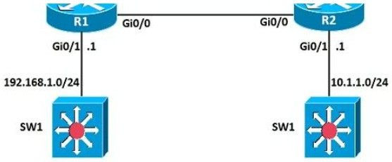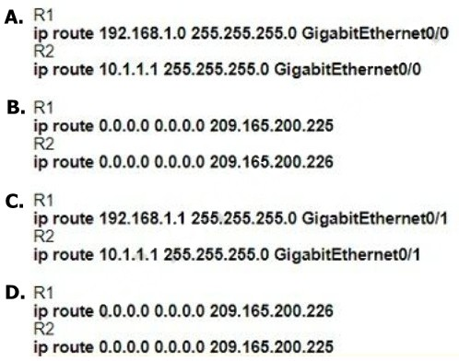Refer to the exhibit. A network engineer is in the process of establishing IP connectivity between two sites. Routers R1 and R2 are partially configured with IP addressing. Both routers have the ability to access devices on their respective LANs. Which command set configures the IP connectivity between devices located on both LANs in each site?
22. Option A
23. Option B
24. Option C
25. Option D Answer: C
26. Which type of organization should use a collapsed-core architecture?
27. large and requires a flexible, scalable network design
28. large and must minimize downtime when hardware fails
29. small and needs to reduce networking costs currently
30. small but is expected to grow dramatically in the near future Answer: C
31. In software-defined architecture, which place handles switching for traffic through a Cisco router?
32. Control
33. Management
34. Data
35. application Answer: C
36. 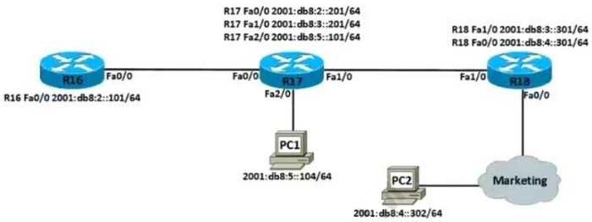Refer to the exhibit. Which IPv6 configuration is required for R17 to successfully ping the WAN interface on R18?

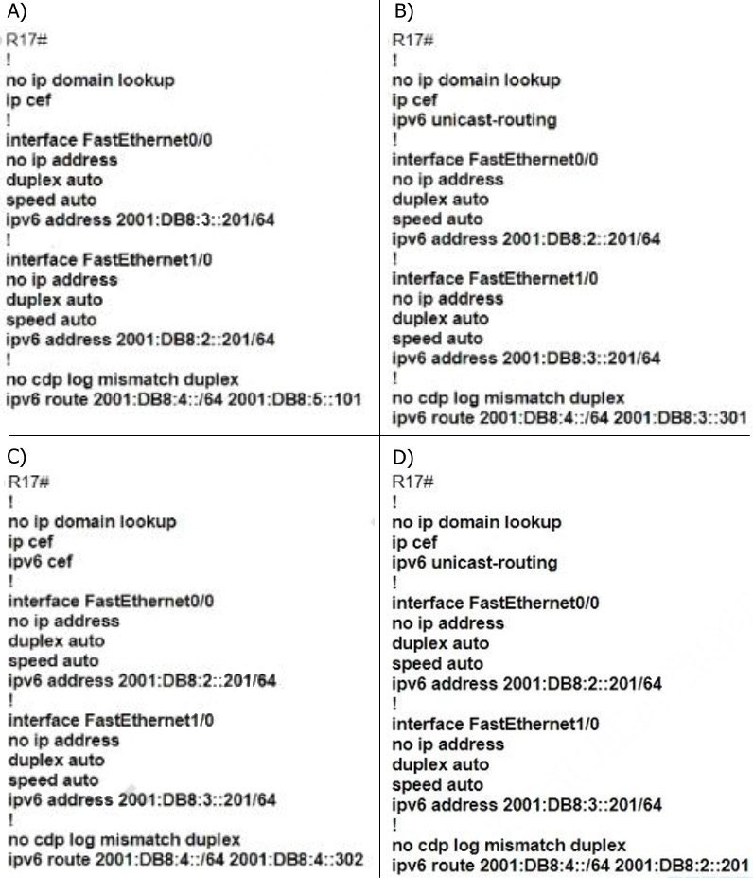

1. Option A
2. Option B
3. Option C
4. Option D Answer: B
5. Refer to the exhibit. Between which zones do wireless users expect to experience intermittent connectivity?
6. between zones 1 and 2

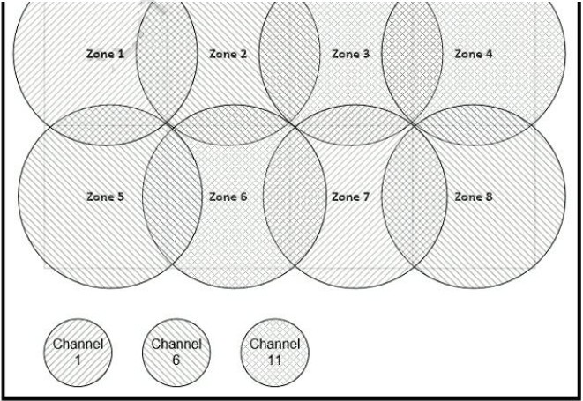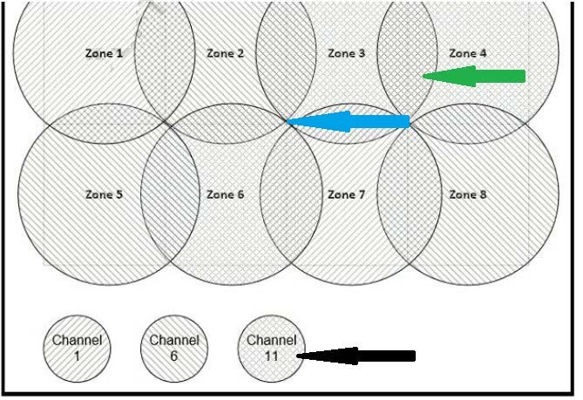

1. between zones 2 and 5
2. between zones 3 and 4
3. between zones 3 and 6 Answer: D

**Drag and Drop**

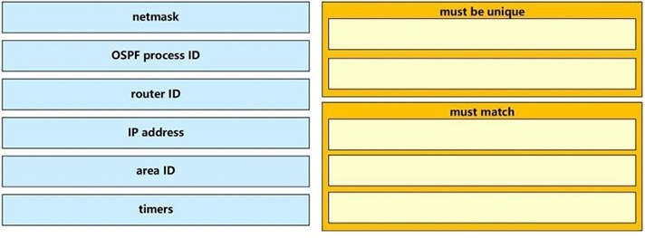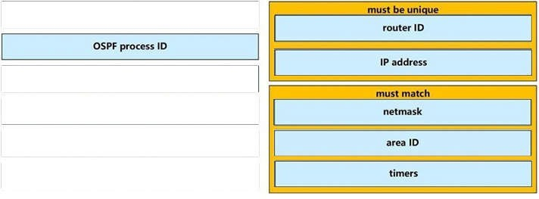

**QUESTION 1**

A network engineer is configuring an OSPFv2 neighbor adjacency. Drag and drop the parameters from the left onto their required categories on the right. No all parameters are used.

**Select and Place:**

**Correct Answer:**

**Section: 3. IP Connectivity Explanation**

**Explanation/Reference:**

**QUESTION 2**

Drag and drop the threat-mitigation techniques from the left onto the types of threat or attack they mitigate on the right.

**Select and Place:**

**Correct Answer:**

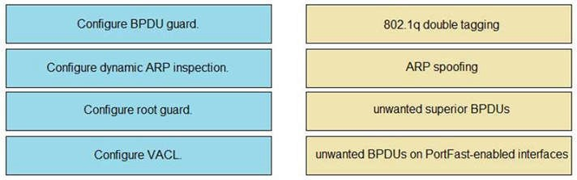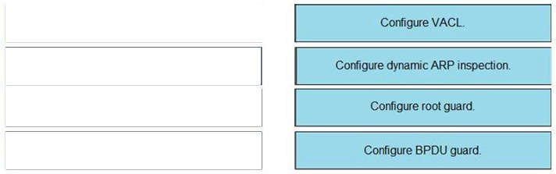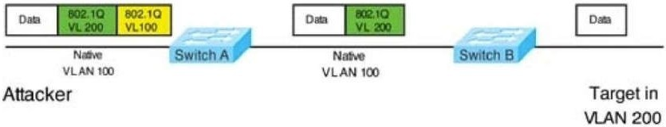

**Section: 5. Security Fundamentals Explanation**

**Explanation/Reference:**

Double-Tagging attack:

In this attack, the attacking computer generates frames with two 802.1Q tags. The first tag matches the native VLAN of the trunk port (VLAN 10 in this case), and the second matches the VLAN of a host it wants to attack (VLAN 20).

When the packet from the attacker reaches Switch A, Switch A only sees the first VLAN 10 and it matches with its native VLAN 10 so this VLAN tag is removed. Switch A forwards the frame out all links with the same native VLAN 10. Switch B receives the frame with an tag of VLAN 20 so it removes this tag and forwards out to the Victim computer.

Note: This attack only works if the trunk (between two switches) has the same native VLAN as the attacker. To mitigate this type of attack, you can use VLAN access control lists (VACLs, which applies to all traffic within a VLAN. We can use VACL to drop attacker traffic to specific victims/servers) or implement Private VLANs.

ARP attack (like ARP poisoning/spoofing) is a type of attack in which a malicious actor sends falsified ARP messages over a local area network as ARP allows a gratuitous reply from a host even if an ARP request was

not received. This results in the linking of an attacker's MAC address with the IP address of a legitimate computer or server on the network. This is an attack based on ARP which is at Layer 2.

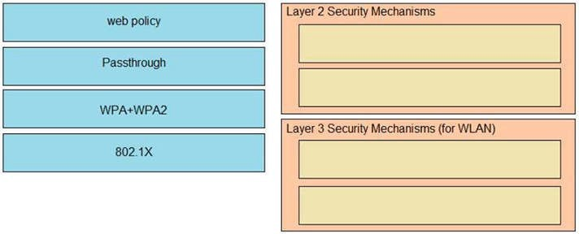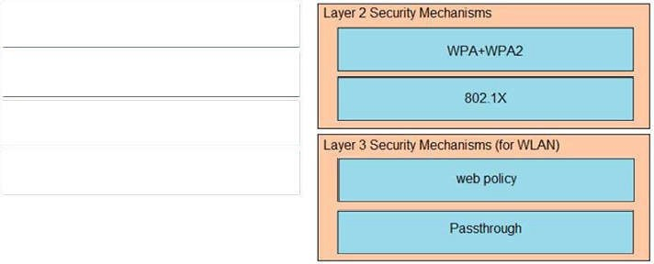

Dynamic ARP inspection (DAI) is a security feature that validates ARP packets in a network which can be used to mitigate this type of attack.

**QUESTION 3**

Drag and drop the Cisco Wireless LAN Controller security settings from the left onto the correct security mechanism categories on the right

**Select and Place:**

**Correct Answer:**

**Section: 5. Security Fundamentals Explanation**

**Explanation/Reference:**

Layer 2 Security Mechanism includes WPA+WPA2, 802.1X, Static WEP, CKIP while Layer 3 Security Mechanisms (for WLAN) includes IPSec, VPN Pass-Through, Web Passthrough ...

Reference: Click here

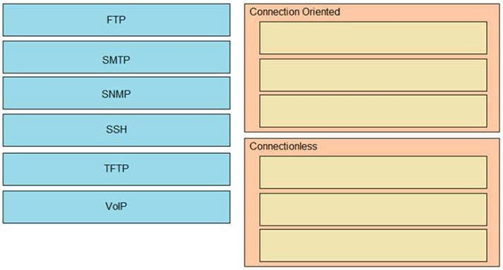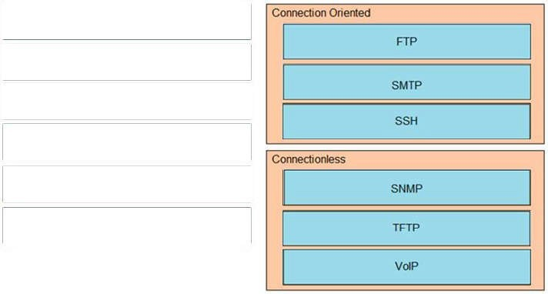

**QUESTION 4**

Drag and drop the network protocols from the left onto the correct transport services on the right.

**Select and Place:**

**Correct Answer:**

**Section: 4. IP Services Explanation**

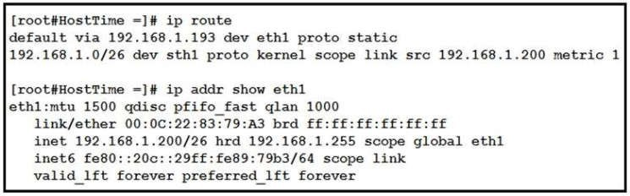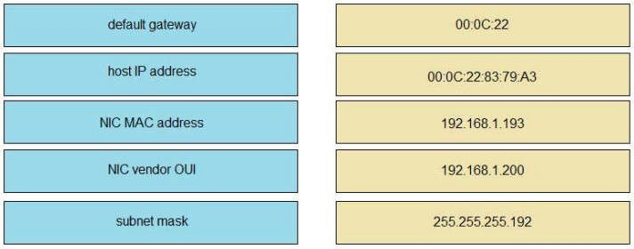

**Explanation/Reference:**

SSH uses TCP port 22 while SNMP uses UDP port 161 and 162.

**QUESTION 5**

Refer to the exhibit.

Drag and drop the networking parameters from the left onto the correct values on the right.

**Select and Place:**

**Correct Answer:**

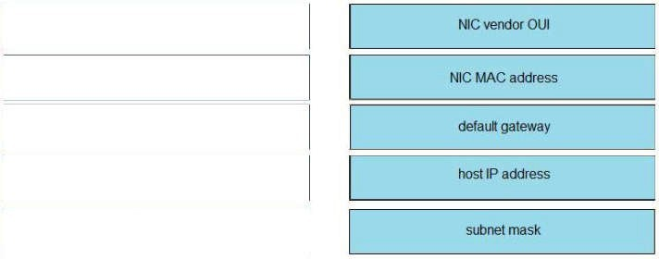

**Section: 1. Network Fundamentals Explanation**

**Explanation/Reference:**

The "ip route" and "ip addr show eth1" are Linux commands.

+ "ip route": display the routing table

+ "ip addr show eth1": get depth information (only on eth1 interface) about your network interfaces like IP Address, MAC Address information

**QUESTION 6**

Drag and drop the AAA functions from the left onto the correct AAA services on the right.

**Select and Place:**

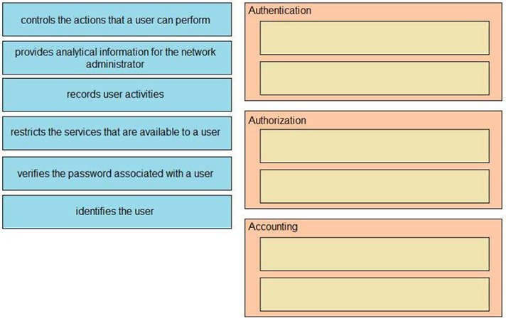

**Correct Answer:**

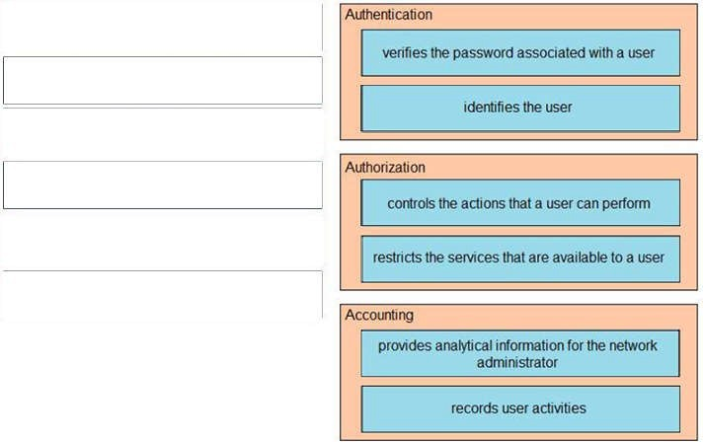

**Section: 5. Security Fundamentals Explanation**

**Explanation/Reference:**

**QUESTION 7**

Drag and drop the IPv4 network subnets from the left onto the correct usable host ranges on the right.

**Select and Place:**

**Correct Answer:**

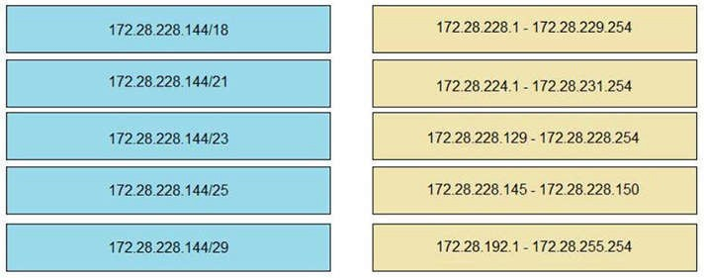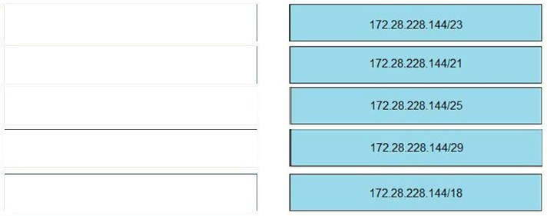

**Section: Not categorized Explanation**

**Explanation/Reference:**

This subnet question requires us to grasp how to subnet very well. To quickly find out the subnet range, we have to find out the increment and the network address of each subnet. Let's take an example with the subnet 172.28.228.144/18:

From the /18 (= 1100 0000 in the 3rd octet), we find out the increment is 64. Therefore the network address of this subnet must be the greatest multiple of the increment but not greater than the value in the 3rd octet (228). We can find out the 3rd octet of the network address is 192 (because 192 = 64 * 3 and 192 < 228) -> The network address is 172.28.192.0. So the first usable host should be 172.28.192.1 and it matches with the 5th answer on the right. In this case we don't need to calculate the broadcast address because we found the correct answer.

Let's take another example with subnet 172.28.228.144/23 -> The increment is 2 (as /23 = 1111 1110 in 3rd octet) -> The 3rd octet of the network address is 228 (because 228 is the multiply of 2 and equal to the 3rd octet) -> The network address is 172.28.228.0 -> The first usable host is 172.28.228.1. It is not necessary but if we want to find out the broadcast address of this subnet, we can find out the next network address, which is 172.28.(228 + the increment number).0 or 172.28.230.0 then reduce 1 bit -> 172.28.229.255 is the broadcast address of our subnet.

Therefore the last usable host is 172.28.229.254.

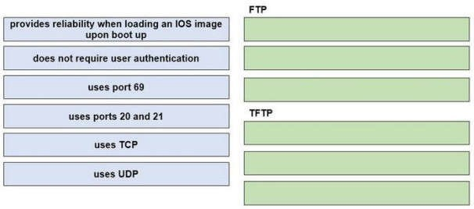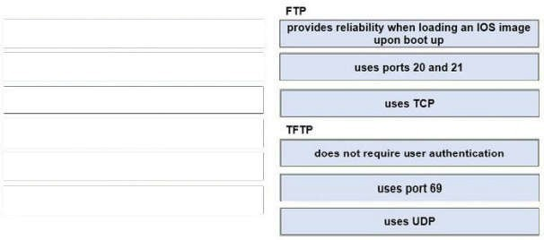

**QUESTION 8**

Drag and drop the descriptions of file-transfer protocols from the left onto the correct protocols on the right.

**Select and Place:**

**Correct Answer:**

**Section: 1. Network Fundamentals Explanation**

**Explanation/Reference:**

**QUESTION 9**

Drag drop the descriptions from the left on to the correct configuration-management technologies on the right.

**Select and Place:**

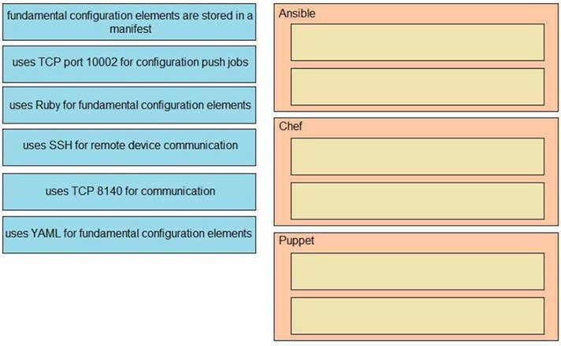

**Correct Answer:**

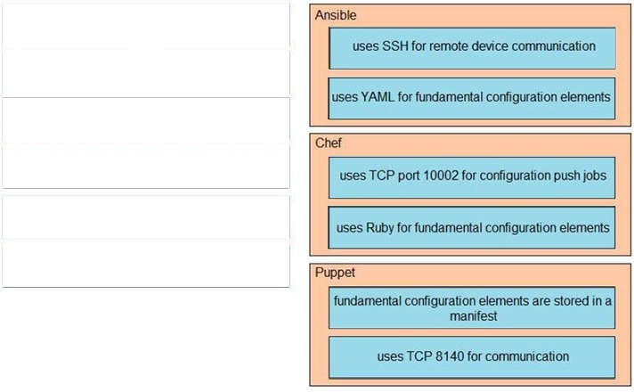

**Section: 6. Automation and Programmability Explanation**

**Explanation/Reference:**

The focus of Ansible is to be streamlined and fast, and to require no node agent installation.

Thus, Ansible performs all functions over SSH. Ansible is built on Python, in contrast to the Ruby foundation of Puppet and Chef.

TCP port 10002 is the command port. It may be configured in the Chef Push Jobs configuration file . This port allows Chef Push Jobs clients to communicate with the Chef Push Jobs server.

Puppet is an open-source configuration management solution, which is built with Ruby and offers custom Domain Specific Language (DSL) and Embedded Ruby (ERB) templates to create custom Puppet language files, offering a declarative-paradigm programming approach.

A Puppet piece of code is called a manifest, and is a file with .pp extension.

**QUESTION 10**

Drag and drop the WLAN components from the left onto the correct descriptions on the right.

**Select and Place:**

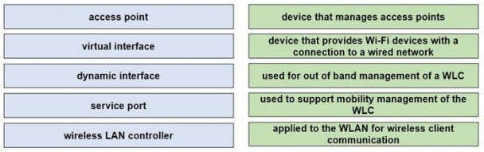

**Correct Answer:**

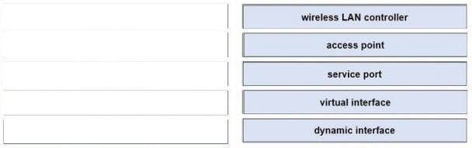

**Section: 2. Network Access Explanation**

**Explanation/Reference:**

The service port can be used management purposes, primarily for out-of-band management.

However, AP management traffic is not possible across the service port. In most cases, the service port is used as a "last resort" means of accessing the controller GUI for management purposes. For example, in the case where the system distribution ports on the controller are down or their

communication to the wired network is otherwise degraded.

A dynamic interface with the Dynamic AP Management option enabled is used as the tunnel source for packets from the controller to the access point and as the destination for CAPWAP packets from the access point to the controller.

The virtual interface is used to support mobility management, Dynamic Host Configuration Protocol (DHCP) relay, and embedded Layer 3 security such as guest web authentication. It also maintains the DNS gateway host name used by Layer 3 security and mobility managers to verify the source of certificates when Layer 3 web authorization is enabled.

**QUESTION 11**

Drag and drop the functions from the left onto the correct network components on the right.

**Select and Place:**

**Correct Answer:**

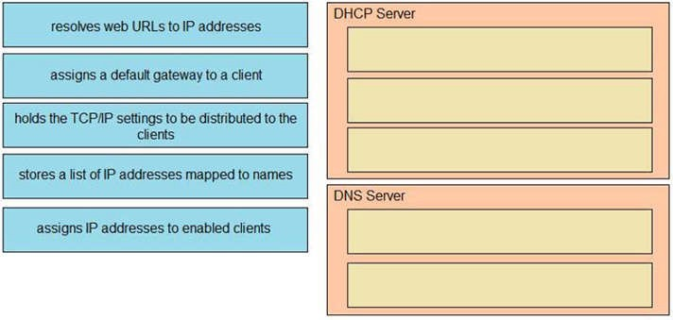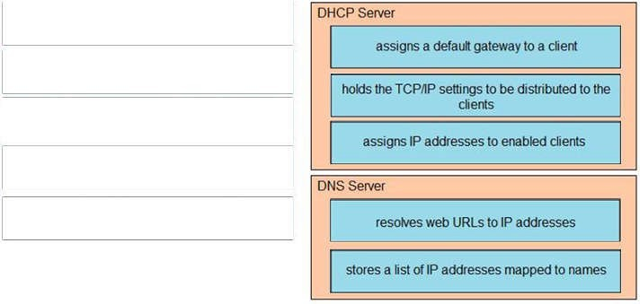

**Section: 4. IP Services Explanation**

**Explanation/Reference:**

**QUESTION 12**

Refer to the exhibit

Drag and drop the routing table components on the left onto the corresponding letter from the exhibit on the right not all options are used.

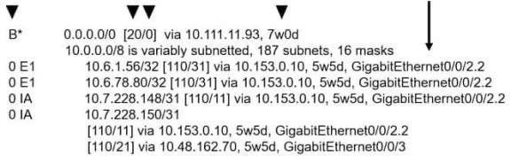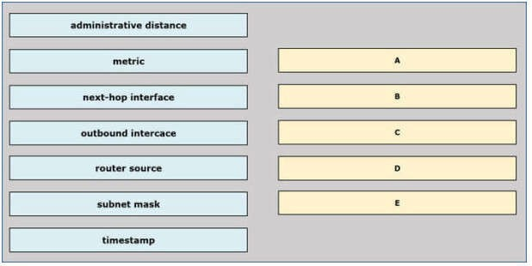

**Select and Place:**

**Correct Answer:**

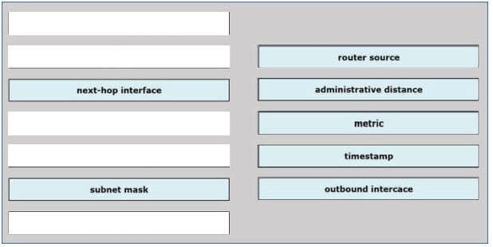

**Section: Not categorized Explanation**

**Explanation/Reference:**

**QUESTION 13**

Drag and drop each broadcast IP address on the left to the Broadcast Address column on the right Not all options are used.

**Select and Place:**

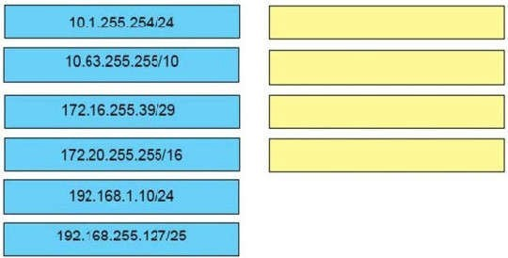

**Correct Answer:**

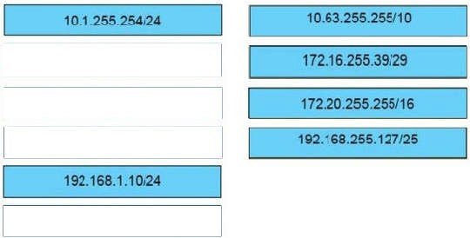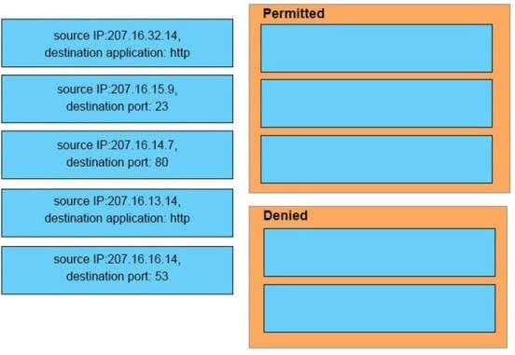

**Section: Not categorized Explanation**

**Explanation/Reference:**

**QUESTION 14**

An interface has been configured with the access list that is shown below.

*access-list 107 deny tcp 207.16.12.0.0.0.3.255 any eq http access-list 107 permit ip any any*

On the basis of that access list, drag each information packet on the left to the appropriate category on the right.

**Select and Place:**

**Correct Answer:**

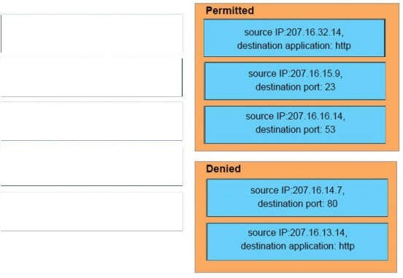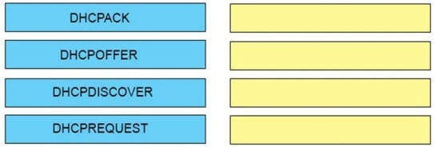

**Section: Not categorized Explanation**

**Explanation/Reference:**

**QUESTION 15**

Order the DHCP message types as they would occur between a DHCP client and a DHCP server.

**Select and Place:**

**Correct Answer:**

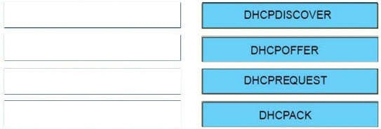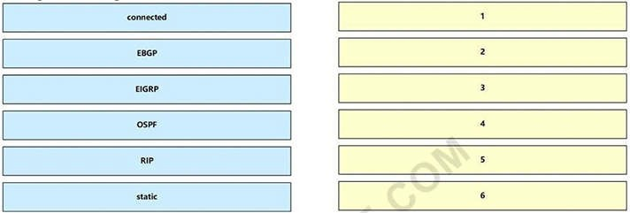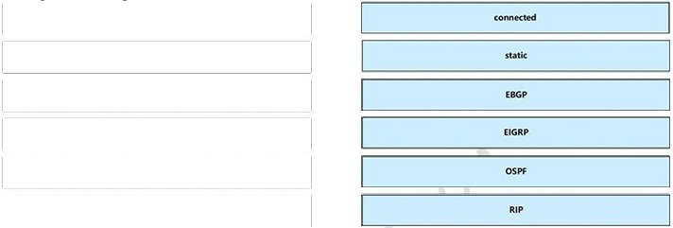

**Section: Not categorized Explanation**

**Explanation/Reference:**

**QUESTION 16**

Drag each route source from the left to the numbers on the right. Beginning with the lowest and ending with the highest administrative distance.

**Select and Place:**

**Correct Answer:**

**Section: (none) Explanation**

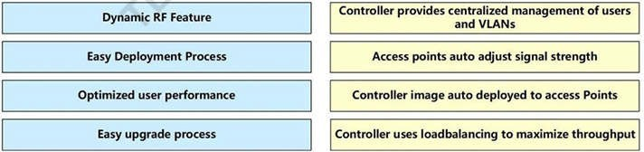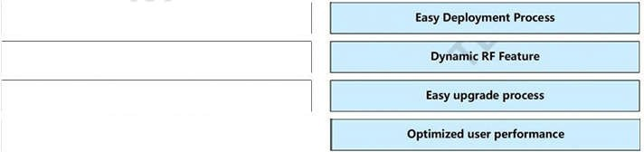

**Explanation/Reference:**

**QUESTION 17**

Drag and drop the benefits of a cisco wireless Lan controller from the left onto the correct examples on the right.

**Select and Place:**

**Correct Answer:**

**Section: (none) Explanation**

**Explanation/Reference:**

**QUESTION 18**

Drag and drop the application protocols from the left onto the transport protocols that is uses on the right.

**Select and Place:**

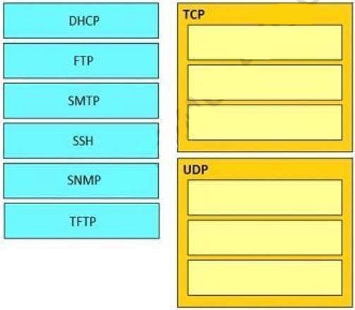

**Correct Answer:**

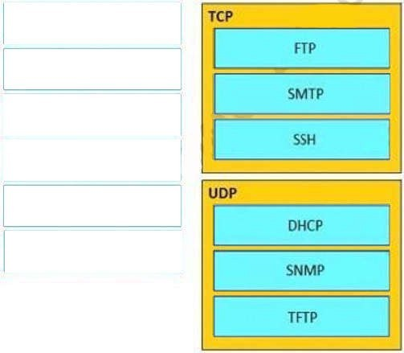

**Section: (none) Explanation**

**Explanation/Reference:**

**QUESTION 19**

Refer to the exhibit. Drag and drop the networking parameters from the left on to the correct values on the right.

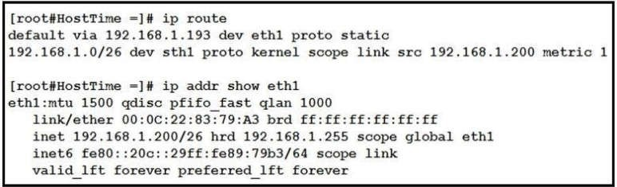

**Select and Place:**

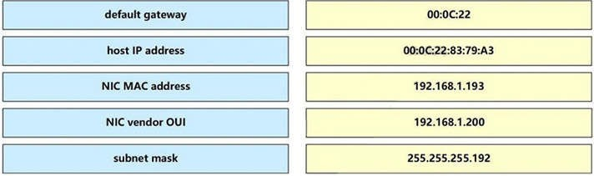

**Correct Answer:**

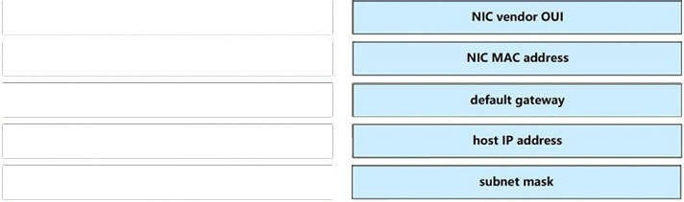

**Section: (none) Explanation**

**Explanation/Reference:**

The “ip route” and “ip addr show eth1” are Linux commands.

+ “ip route”: display the routing table

+ “ip addr show eth1”: get depth information (only on eth1 interface) about your network interfaces like IP Address, MAC Address information

**QUESTION 20**

Drag and drop the networking parameters from the left on to the correct values on the right.

**Select and Place:**

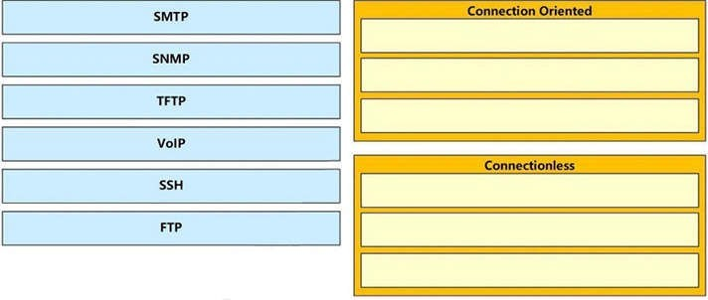

**Correct Answer:**

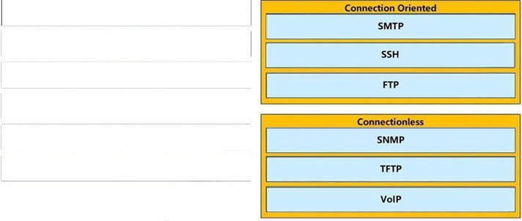

**Section: (none) Explanation**

**Explanation/Reference:**

**QUESTION 21**

Drag and drop to the characteristics of networking from the left onto the correct networking types on the right.

**Select and Place:**

**Correct Answer:**

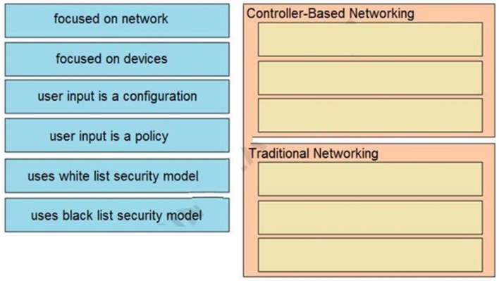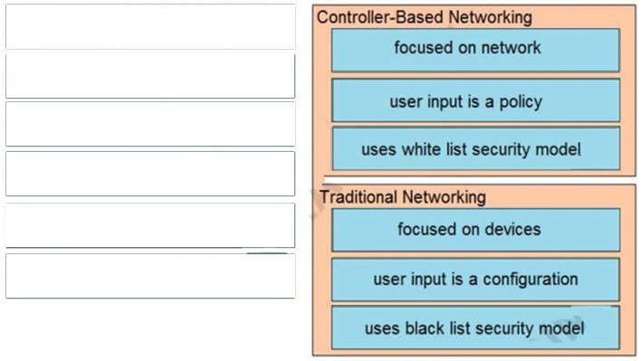

**Section: (none) Explanation**

**Explanation/Reference:**

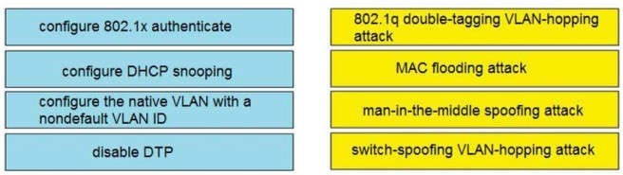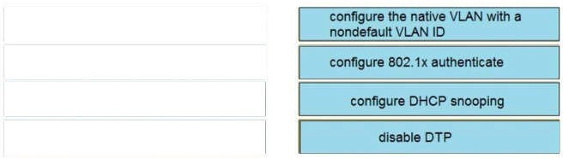

**QUESTION 22**

Drag and drop the attack-mitigation techniques from the left onto the Types of attack that they mitigate on the right.

**Select and Place:**

**Correct Answer:**

**Section: (none) Explanation**

**Explanation/Reference:**

**QUESTION 23**

Match the functions to the corresponding layers. (Not all options are used.)

**Select and Place:**

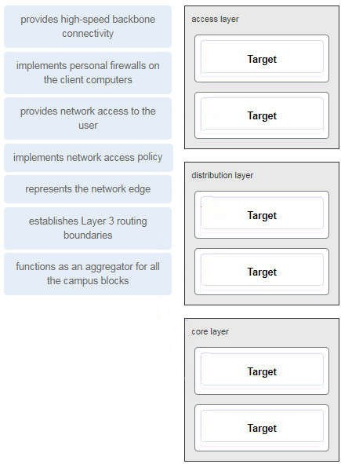

**Correct Answer:**

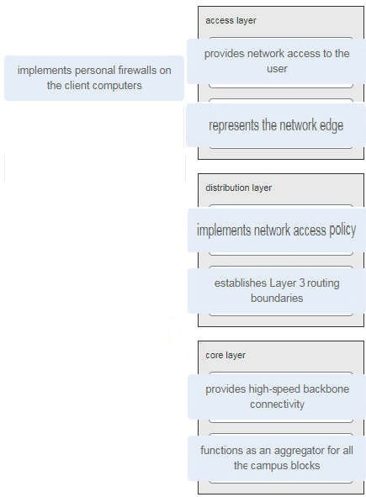

**Section: (none) Explanation**

**Explanation/Reference:**

**QUESTION 24**

Drag the descriptions of device management from the left onto the types of device management on the right.

**Select and Place:**

**Correct Answer:**

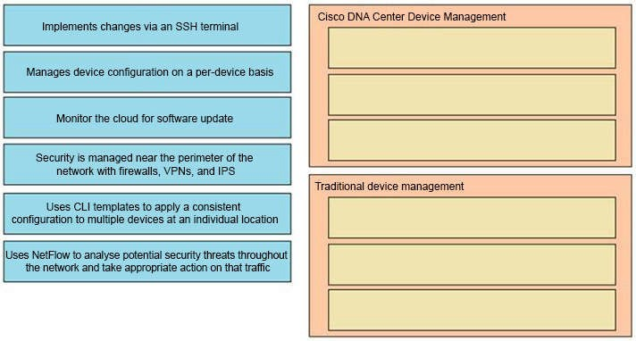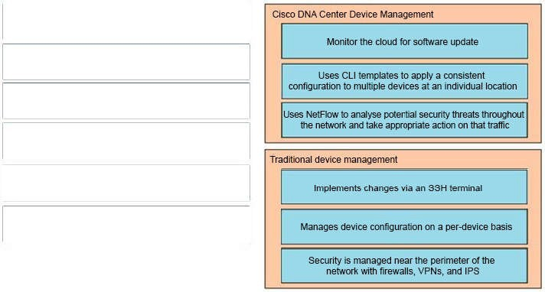

**Section: (none) Explanation**

**Explanation/Reference:**

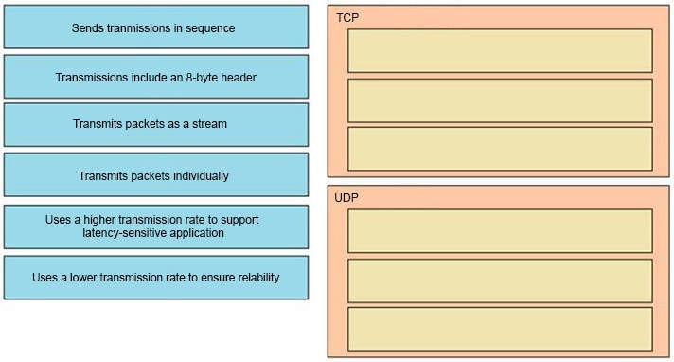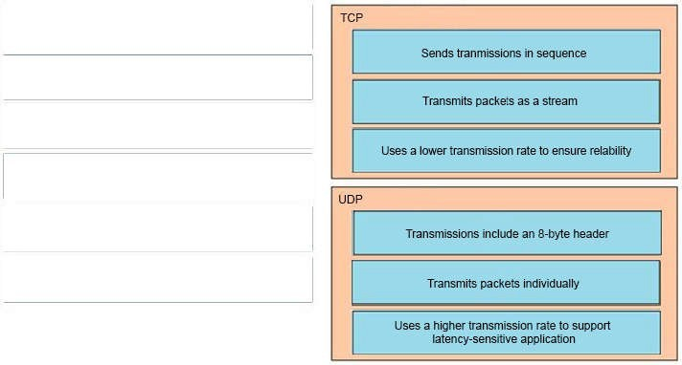

**QUESTION 25**

Drag the descriptions of IP protocol transmissions from the left onto the IP traffic types on the right.

**Select and Place:**

**Correct Answer:**

**Section: (none) Explanation**

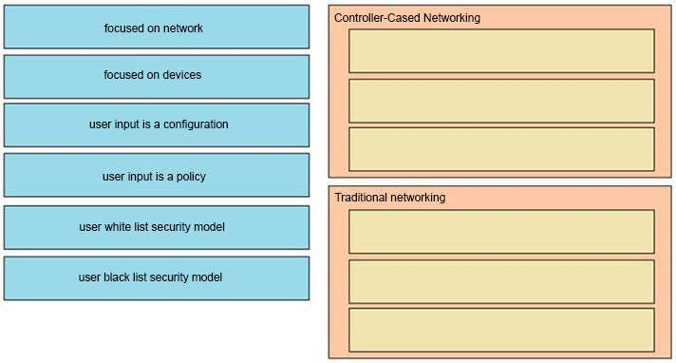

**Explanation/Reference:**

**QUESTION 26**

Drag and drop to the characteristics of networking from the left onto the correct networking types on the right.

**Select and Place:**

**Correct Answer:**

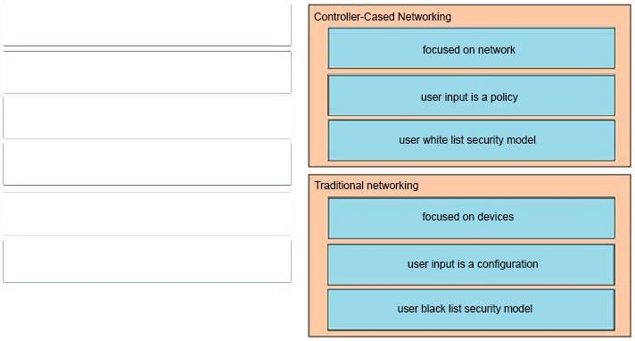

**Section: (none) Explanation**

**Explanation/Reference:**

**QUESTION 27**

Refer to the exhibit.

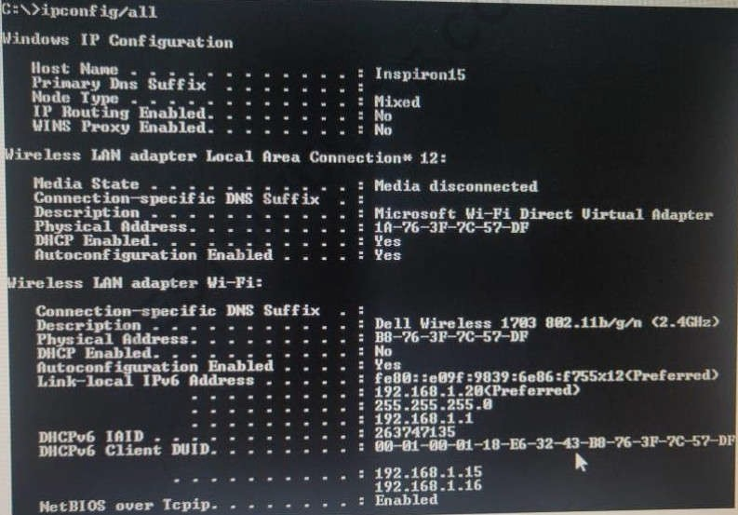

An engineer is tasked with verifying network configuration parameters on a client workstation to report back to the team lead. Drag and drop the node identifiers from the left onto the network parameters on the right.

**Select and Place:**

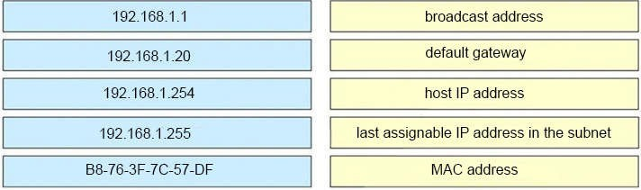

**Correct Answer:**

**Section: (none) Explanation**

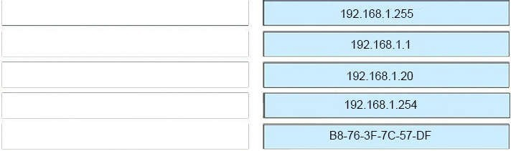

**Explanation/Reference:**

QUESTION 28

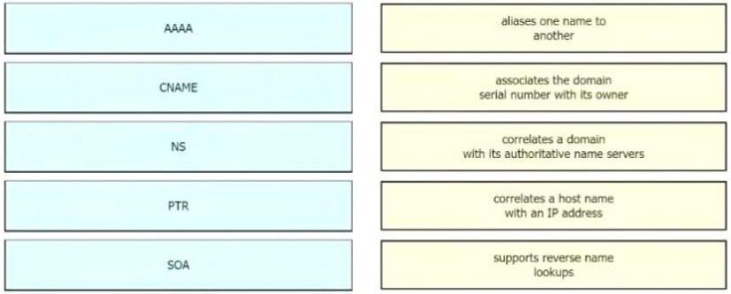Drag the IPv6 DNS record types from the left onto the description on the right.

Answer:

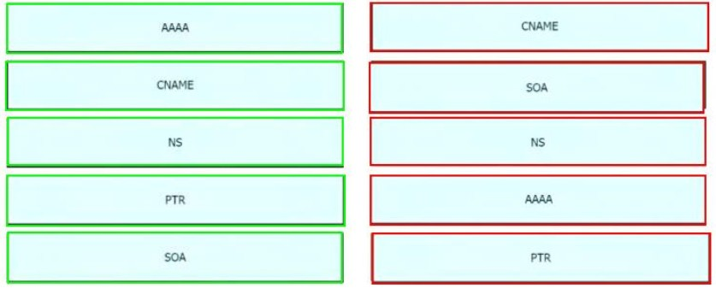

更多首发题库请关注淘宝店铺：华为思科题库汇总

Q29

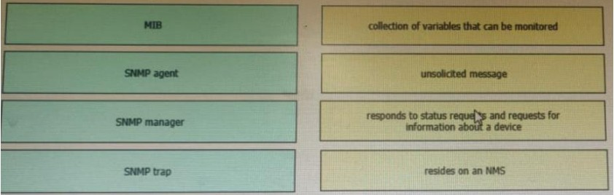Drag and drop the SNMP components from the left onto the descriptions on the right.

Answer:

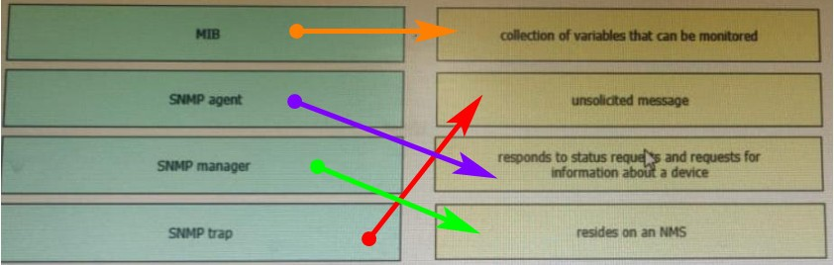

Explanation: MIB: collection of variables that can be monitored

SNMP agent: responds to status requests and requests for information about a device SNMP manager: The SNMP manager is part of an NMS

SNMP trap: unsolicited messages that are sent by the SNMP agent and alert the NMS to a condition on the network

更多首发题库请关注淘宝店铺：华为思科题库汇总

Q30

Drag and drop the QoS congestion management terms from the left onto the description on the right.

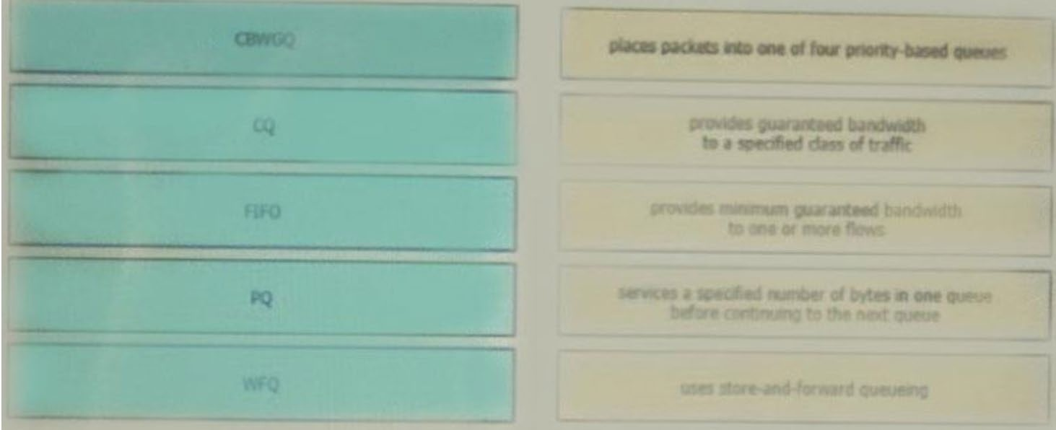

Answer:

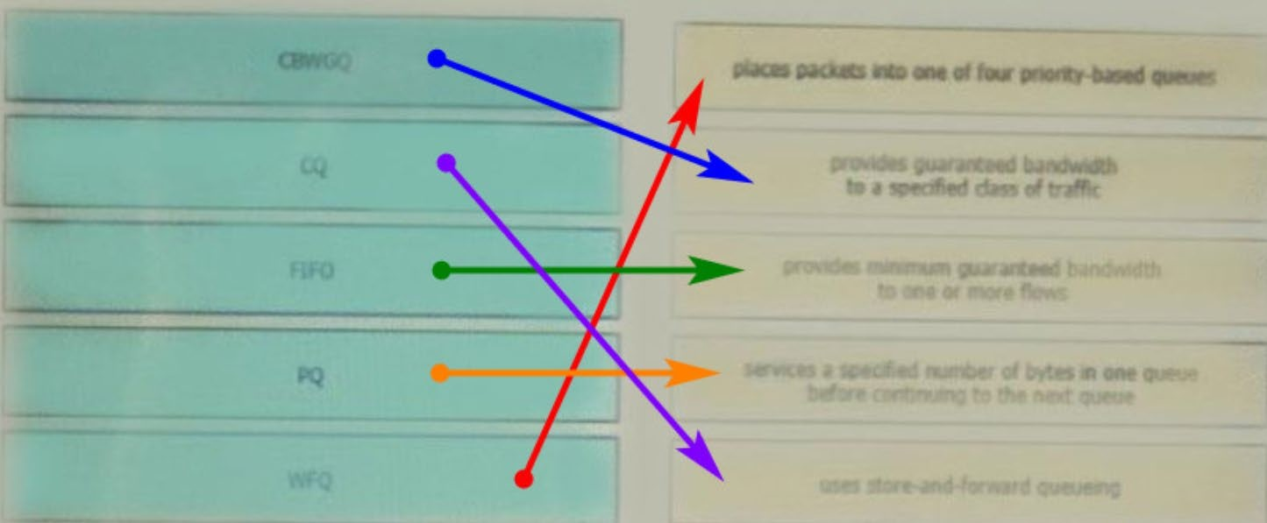

更多首发题库请关注淘宝店铺：华为思科题库汇总

Q31

Drag and drop the DHCP snooping terms from the left onto the descriptions on the right.

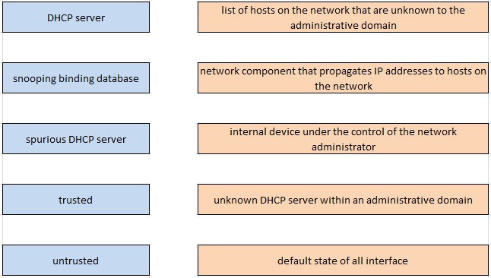

Answer:

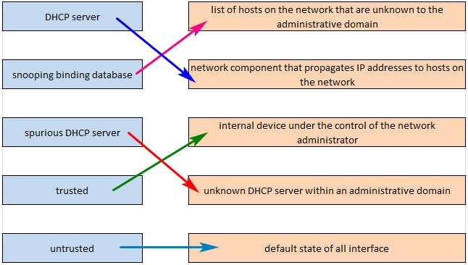

Q32.

Refer to the exhibit.

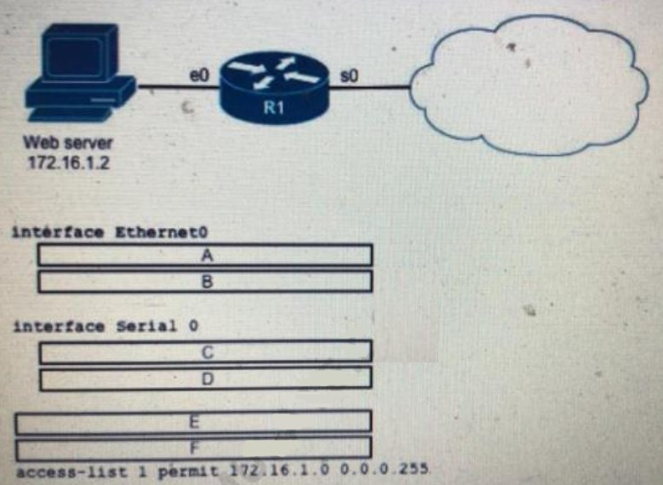

更多首发题库请关注淘宝店铺：华为思科题库汇总

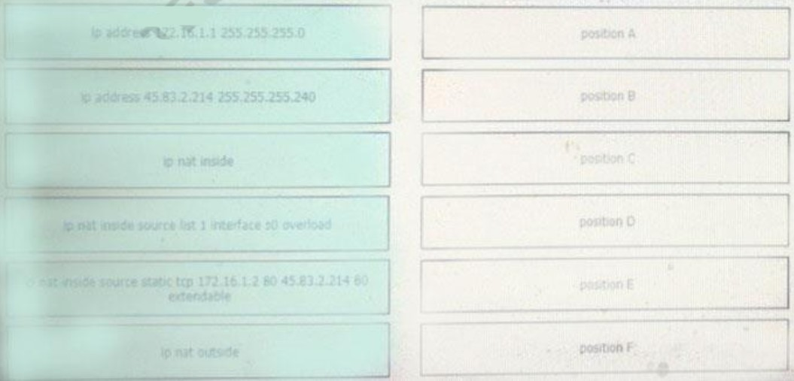An engineer is configuring the router to provide static NAT for the webserver Drag and drop the configuration commands from the left onto the letters that correspond to its position in the configuration on the right.

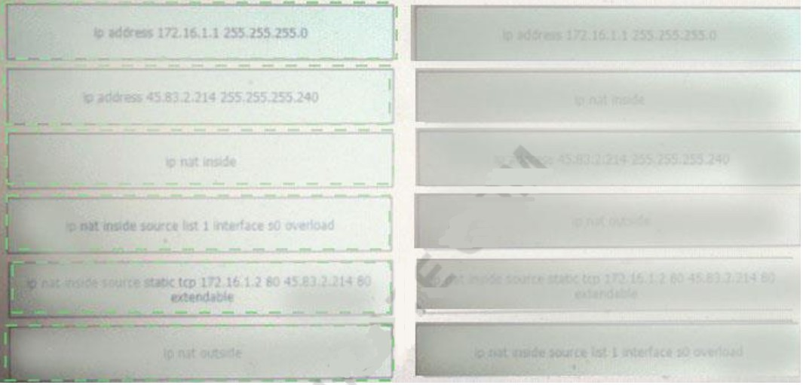

Answer:

更多首发题库请关注淘宝店铺：华为思科题库汇总

1. 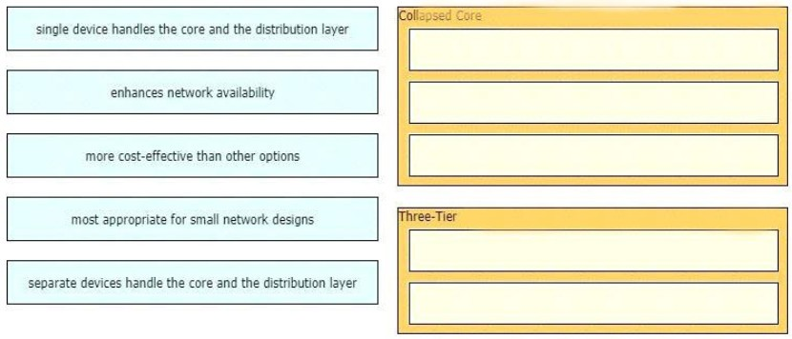Drag and drop the characteristics of network architectures from the left onto the type of architecture on the right.

Answers

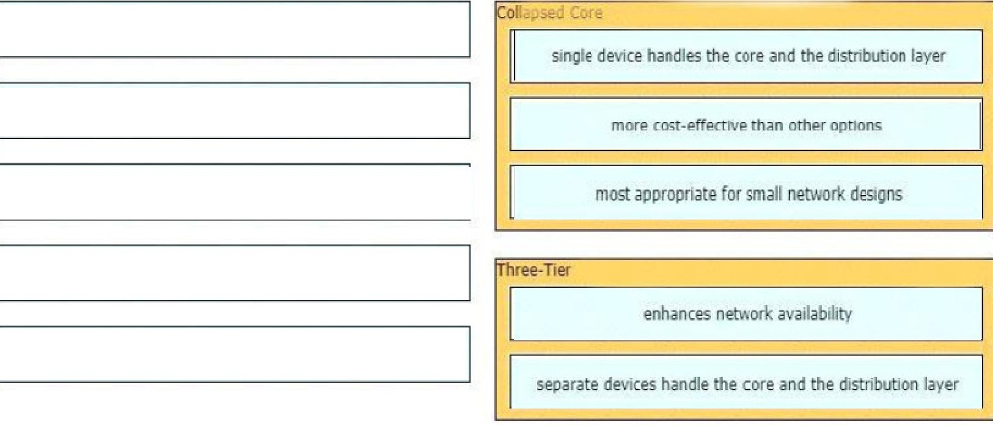

1. Drag and drop the SNMP manager and agent identifier commands from the left onto the functions on the right

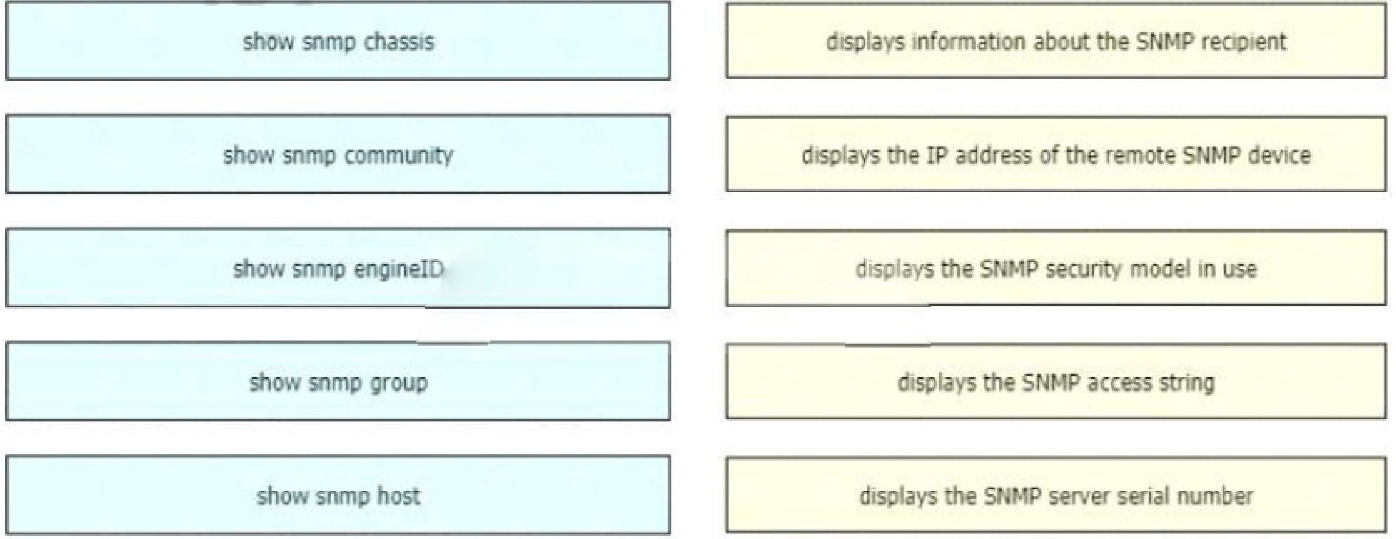

Answers

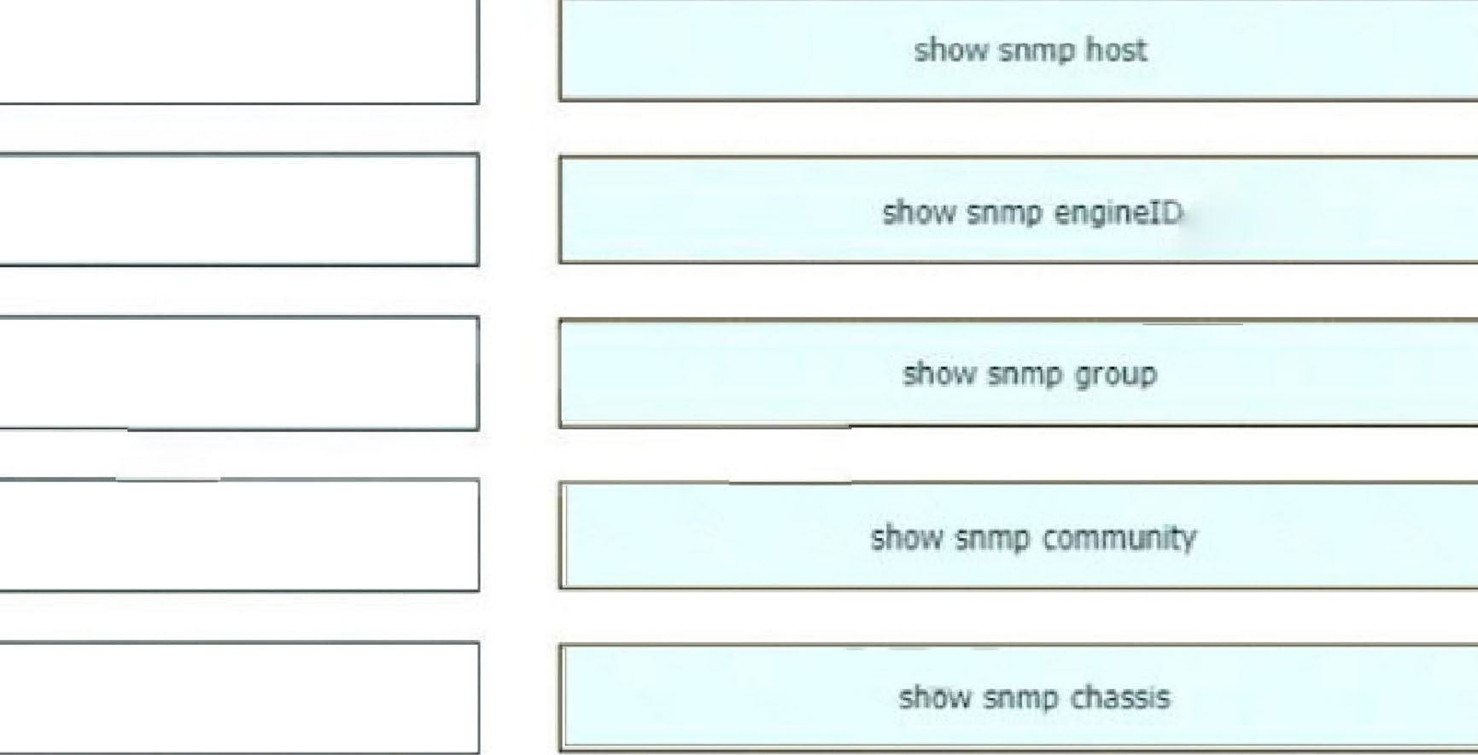

# Drag and drop the TCP/IP protocols from the left onto the transmission protocols on the right

Answer:

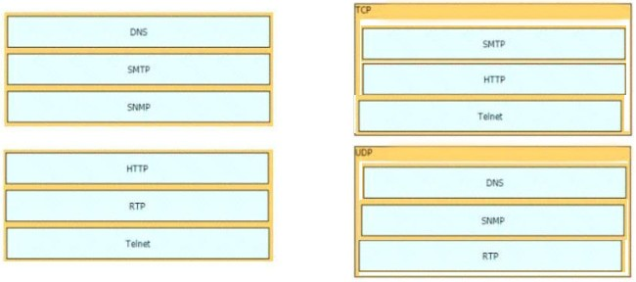

1. Drag and drop the 802.11 wireless standards from the left onto the matching statements on the right

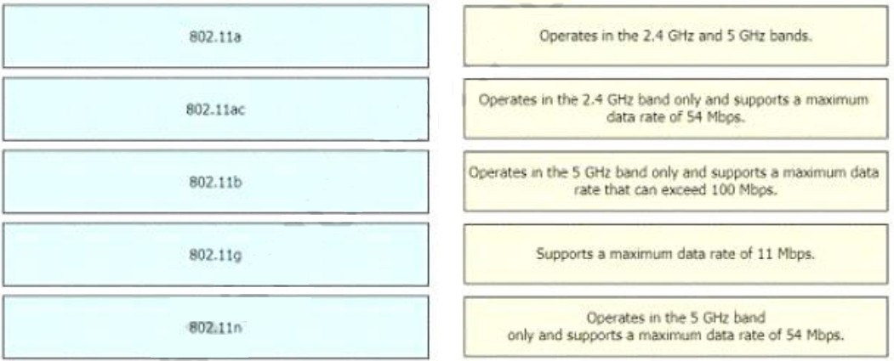

ANSWER：

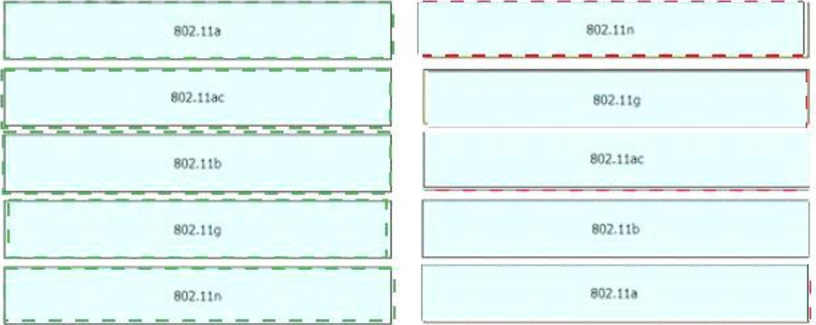

1. Drag and drop the functions of DHCP from the left onto any of the

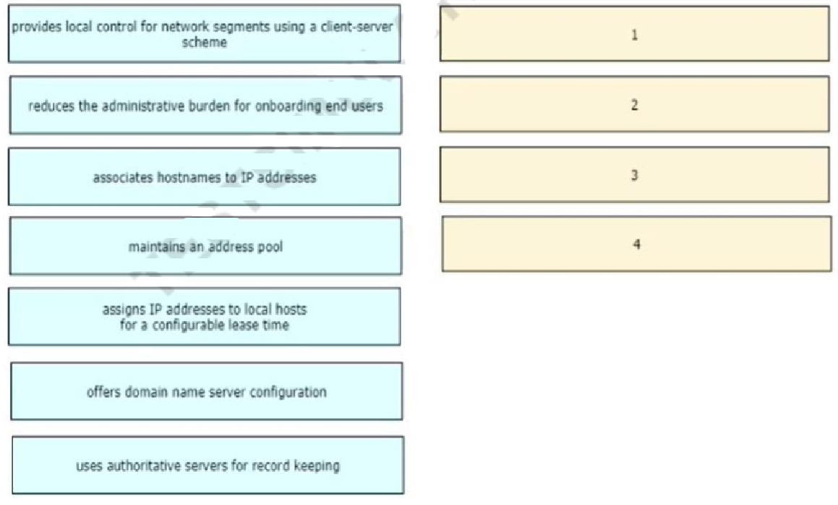

positions on the right (Not all functions are used)

Answer:

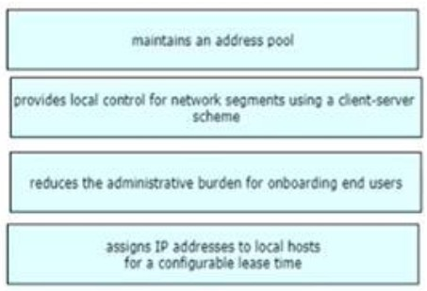

1. Drag and drop the IPv6 address type characteristics from the left to the right

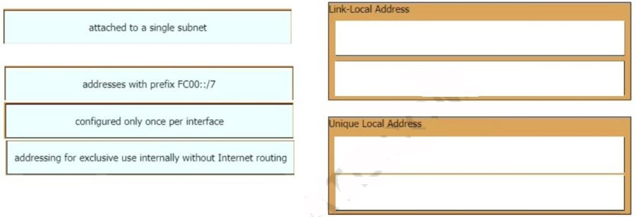

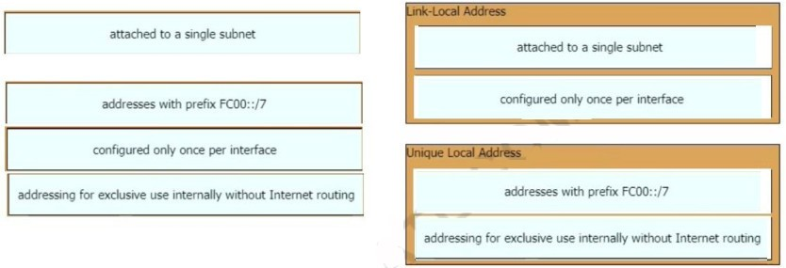

Answer:

Explanation/Reference: “A link-local address is a unicast address that is confined to a single link, a single subnet.”

“There can be only one link-local address per interface.”

“ULA addresses are for devices that never need access to the Internet and never need to be accessible from the Internet.”

Reference: [Click here](https://www.ciscopress.com/articles/article.asp?p=2803866&seqNum=4)

1. An engineer is configuring an encrypted password for the enable command on a router where the local user database has already been configured. Drag and drop the configuration commands from the left into the correct sequence on the right (Not all commands are used)

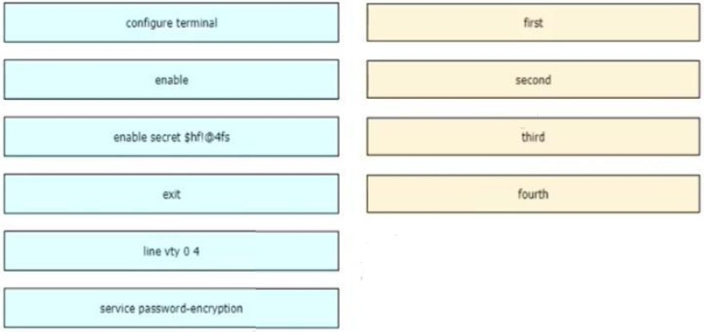

Answer:

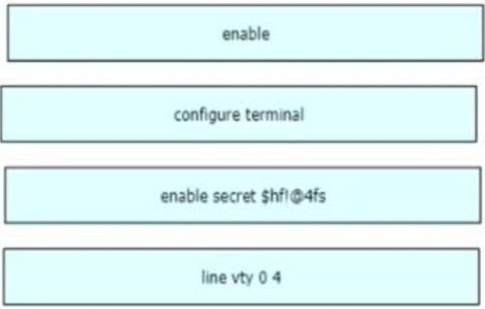

1. Drag and drop the statement about networking from the left into the Corresponding networking types on the right. Not all statements are used.

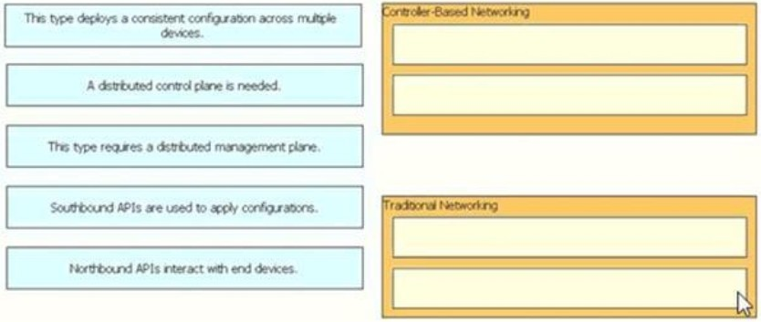

Answer:

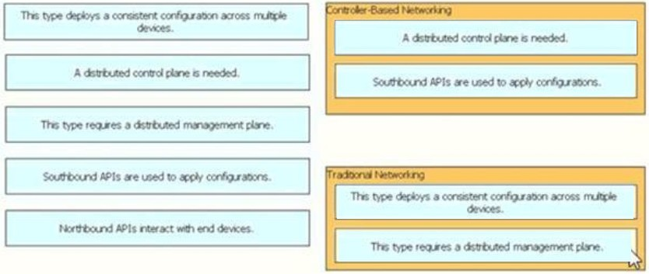

1. Drag and drop the DNS lookup components from the left onto the

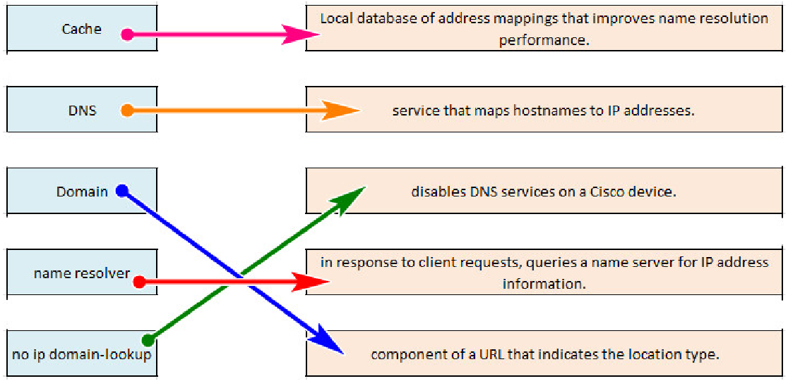

functions on the right.

1. Drag and drop the AAA terms from the left onto the description on the right.

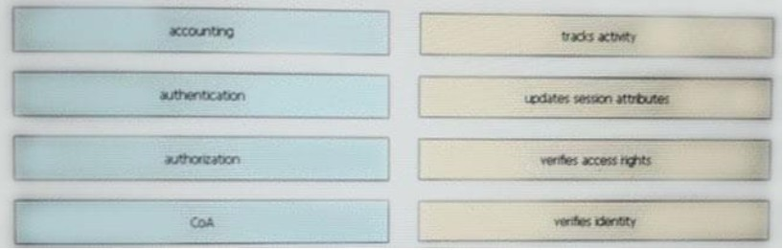Answer:

1. Drag and drop the functions of DHCP from the left onto any of the positions on the right (Not all functions are used)

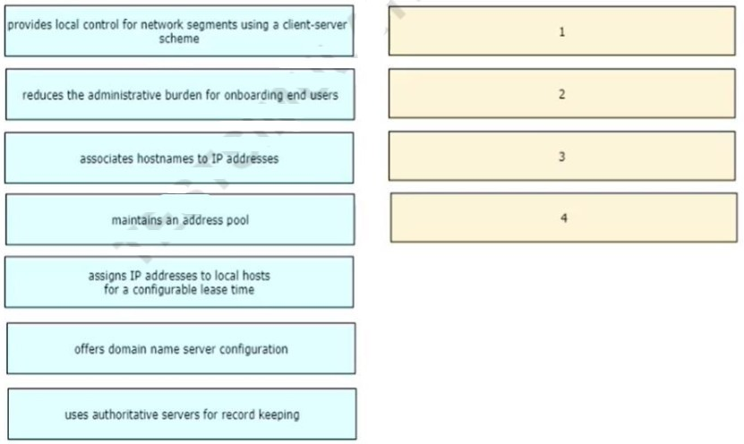

*Answer:*



# Drag and drop the IPv6 address type characteristics from the left to the right



Answer:



Explanation/Reference: “A link-local address is a unicast address that is confined to a single link, a single subnet.”

“There can be only one link-local address per interface.”

“ULA addresses are for devices that never need access to the Internet and

never need to be accessible from the Internet.”

Reference: [Click here](https://www.ciscopress.com/articles/article.asp?p=2803866&seqNum=4)

1. An engineer is configuring an encrypted password for the enable command on a router where the local user database has already been configured. Drag and drop the configuration commands from the left into the correct sequence on the right (Not all commands are used)



Answer:



1. Drag and drop the statement about networking from the left into the Corresponding networking types on the right. Not all statements are used.



Answer:



1. 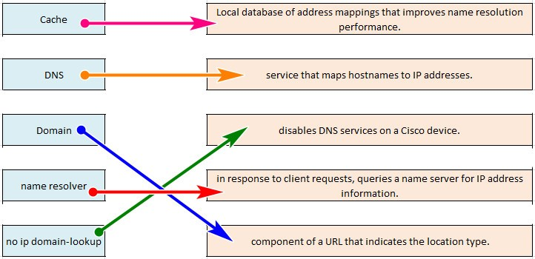Drag and drop the DNS lookup components from the left onto the functions on the right.
2. Drag and drop the AAA terms from the left onto the description on the right.

Answer:

